Introduction 2
What can GTFS-flex do? 2
What does flexible trip planning look like? 3
Demand response 3
Route deviation 4
Continuous stops 5
What else can GTFS-flex do? 7
Program Finders 7
Mapping service areas 7
Considerations for booking and real-time 8
How does GTFS-flex work? 9
How did GTFS-flex originate? 13
Mobility on Demand (MOD) Sandbox Project 13
MobilityData stewardship 13
OpenTripPlanner development 14
How is GTFS-flex used today? 14
Northwest Oregon Transit Alliance (NW Connector) 14
Vamos Mobility 16
Denver RTD 17
Google Maps 17
GTFS-flex Vendors 17
What should I do with GTFS-flex? 17
Projects for 2020 and 2021 18
Flag Stops in Google Maps 18
Regional Flexible Trip Planners 19
Directories and Website Integration 19
Request in “MaaS” or “Microtransit” Projects 19
GTFS-flex in the Future 20
Reservations and Real-Time Booking 20
Brokerages and Sharing Trips 20
A More Competitive and Equitable Market 20

Introduction
GTFS-flex is a proposed extension to the General Transit Feed Specification (“GTFS”), a data standard that organizes transit schedule data into formats that are transferable between online systems—most notably trip planning apps. There are over 2,500 agencies worldwide that publish GTFS data, over a thousand of which are in the United States. Many customer apps consume GTFS, including:
- Google Maps
- Microsoft Bing Maps
- Apple Maps
- TransitScreen
- Transit
- Rome2Rio
Other transit technology systems like Automated Passenger Counters and Automated Vehicle Location systems use GTFS data as well.

And yet, despite the prevalence of fixed-route GTFS data for transit systems around the world, the current specification does not represent the flexible services that make up the vast majority of transit. Demand response transportation alone accounts for over half of all transit services in the U.S., in part, owing to the Americans with Disabilities Act requirement that every fixed-route transit system provide comparable paratransit. GTFS-flex is a community effort to expand the scope of GTFS to make online trip planning and data exchange equally accessible to all transit services and users.

What can GTFS-flex do?
GTFS-flex exists to bring flexible transit services to trip planners—applications that provide travelers with navigational directions for multiple modes of travel between user-defined points. GTFS data informs a trip planner’s transit directions, but only for fixed-route systems. GTFS-flex adds modeling of demand response, continuous stops, route deviation, and other non-fixed-route services to GTFS. A GTFS-flex-enabled trip planner can read these additional categories of transit data and generate matching itineraries, giving a user more trip options in search results.

GTFS Trip Planner | GTFS-flex Trip Planner
- Itineraries  - Departure and arrival estimates  - Mapping  - Fare information  - Fixed-route services  - Demand response transportation  - Route deviation  - Continuous stops  - Flag stops (or Hail-and-ride)  - Point deviation  - Point-to-zone  - Custom rider messages  - Eligibility information | - Itineraries  - Departure and arrival estimates  - Mapping  - Fare information  - Fixed-route services  and:  - Demand response transportation  - Route deviation  - Continuous stops  - Flag stops (or Hail-and-ride)  - Point deviation  - Point-to-zone  - Custom rider messages  - Eligibility information
Comparison of features between GTFS and GTFS-flex trip planners

What does flexible trip planning look like?
Flexible trip planning looks similar to regular trip planning except for a few factors. First, a flexible trip itinerary will include a brief message conveying the unique rules of the service. Second, because some flexible services often have eligibility or reservation requirements, a flexible trip planner may have the option to include or exclude those services in search results. Lastly, because a flexible trip planner models a range of one-of-a-kind services, the particular details of an itinerary will look different from service to service. This section illustrates GTFS-flex trip planning for three common flexible services and includes a hypothetical rider walkthrough for each.

Demand response
Demand response refers to transportation services in which a vehicle picks up and drops off a rider anywhere within a specified area (e.g. dial-a-ride or paratransit). A demand response itinerary will display if a user’s trip falls within the demand response service area and days and hours of operation. Demand response services only operate when riders have scheduled a trip through the agency, so the itinerary will list booking information. Flexible trip planners also include any applicable eligibility information for eligibility-based services like ADA paratransit.

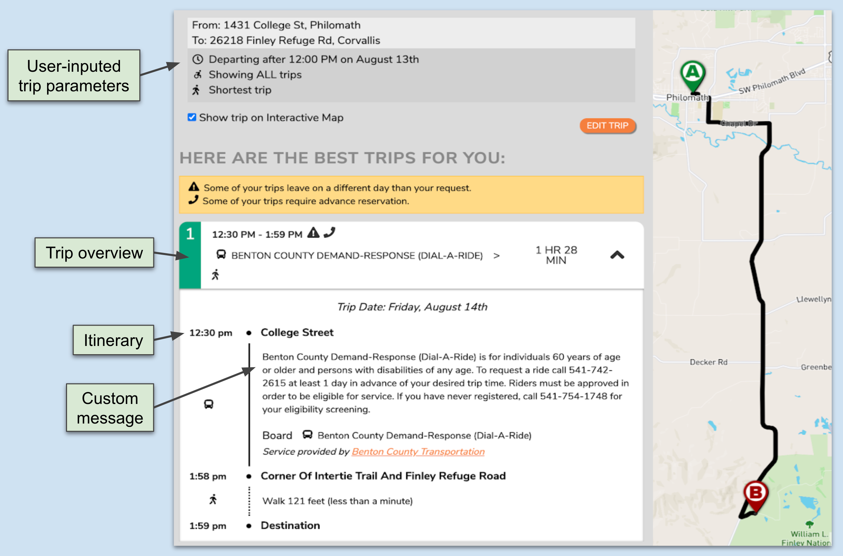
Demand response trip plan

Hypothetical rider walkthrough

Joey has a disability that makes it difficult for him to drive a car. He lives in a small, rural county with one demand response transit service. Sometimes, Joey can get a ride from a family member, but his family is not always available when he needs transportation. Joey wants to find a more reliable mode of transportation to access social services on his terms. Joey navigates to his regional trip planning web app, inputs a trip query, and discovers there is a county dial-a-ride service. He also sees instructions on how to schedule a ride and how much it will cost. He calls the number listed and books a trip for the next day.

Route deviation
Route deviation describes fixed-route services in which the vehicle can deviate from the regular path-of-travel to pick up and/or drop off riders. This is commonly expressed as a buffer (for example, one mile) along the route within which the vehicle can travel to serve riders and then return to its regular course. To see route deviation results in a trip planner, a user inputs an origin-destination pair as they would for a regular trip plan. If the closest matching route deviates, the accompanying map will describe that deviation. Additionally, any rules for using the service will display, such as whether the deviation requires advance reservation, and if so, a number to call.

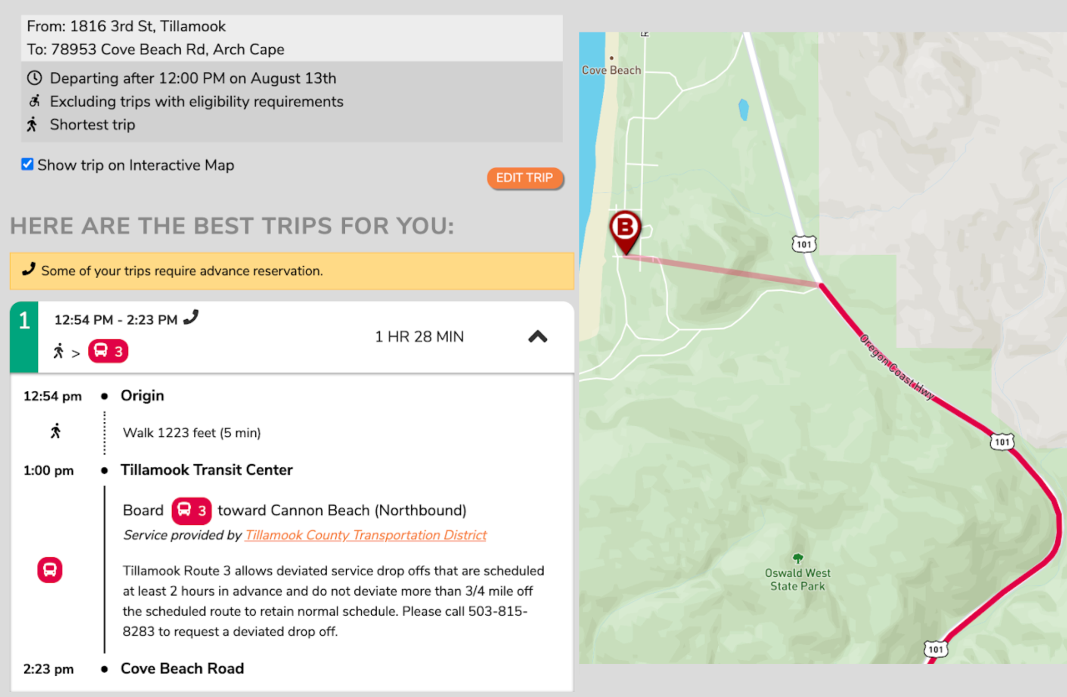
Route deviation trip plan

Hypothetical rider walkthrough

Carmen is a university student visiting her family living in a midsize city. While visiting, Carmen relies on the city’s bus service, although its coverage is inconsistent in her family’s area. Buses can deviate up to ¾ mile, but finding the rules surrounding those deviations is an onerous task, especially on-the-go. As Carmen waits for the bus, she pulls out her phone and instead of using a search engine, opens a trip planning app. She then inputs a trip query to see if the bus can deviate to her destination at her desired time of arrival. Based on the trip planner’s results—tailored to her circumstance—she makes a request to the driver for a deviation from the route as she boards.

Continuous stops
This describes fixed-route services in which a rider can board and/or alight at a location between system stops along the route. A rider waits by the road and signals to the driver of the approaching vehicle that they wish to board. Once aboard, the passenger can alight at a regular stop, or if the service allows, coordinate with the driver to alight at a different location along the route. The trip planner will return a continuous stop itinerary if a trip’s start or endpoint is within walking distance of a fixed-route, but not near one of its stops. The trip planning app displays the continuous stop as either a start or endpoint along the path of travel and includes information on how to request pickup/drop off from that location.

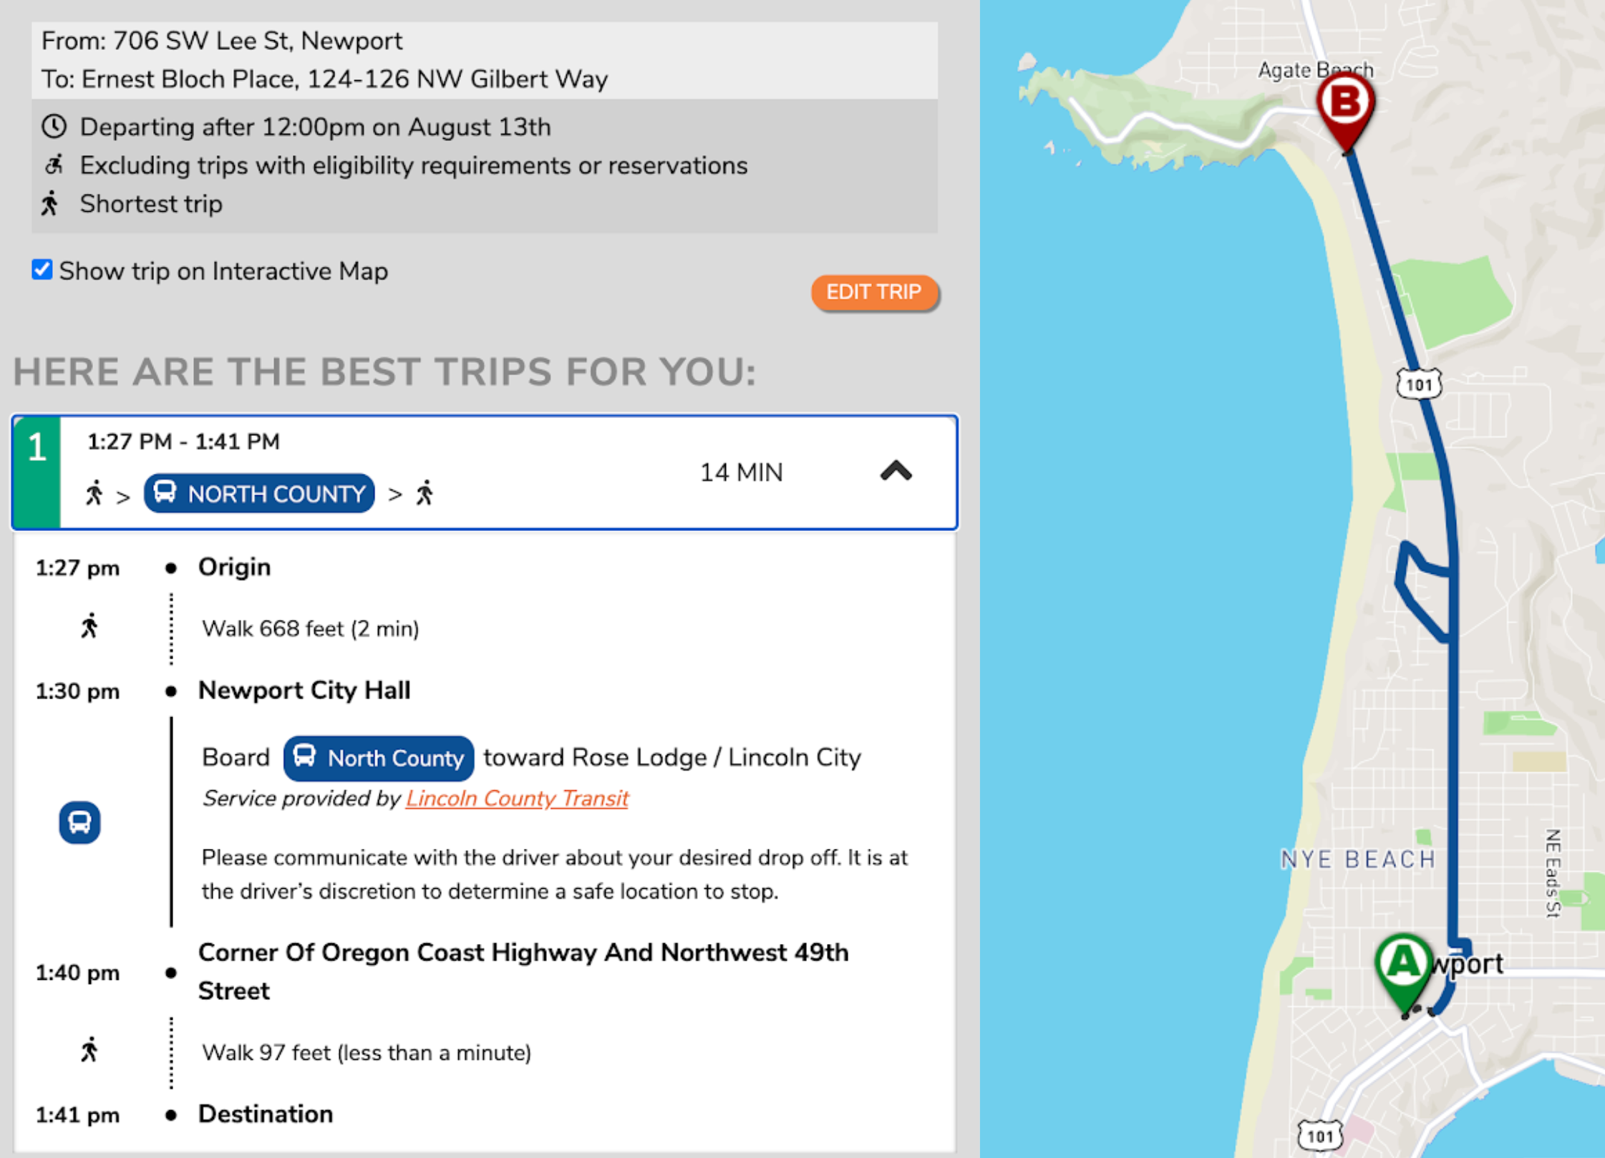
Continuous stops trip plan

Hypothetical rider walkthrough

Ashley lives outside a large city and uses transit to commute to her job. She takes a bus to the city center and then rents an e-scooter for the last mile of the trip. Because e-scooter locations can vary day-to-day, it is sometimes more convenient for Ashley to alight at a point between stops if the closest e-scooter available is not near a stop. Before she reserves an e-scooter, she inputs its coordinates as a destination in Google Maps to confirm that it lies within a continuous stopping zone. Seeing that it does, Ashley reserves the e-scooter and communicates with the driver that she would like to get off a quarter of a mile before the next stop. Ashley disembarks, walks a few paces to reach the e-scooter, and rides it for the remainder of her commute.

In these scenarios, GTFS-flex helped Joey discover a dial-a-ride service that increased his mobility independence, simplified Carmen’s process for understanding how to fully access her city’s transit, and empowered Ashley in making on-the-go travel decisions easier. Not only does GTFS-flex improve the experience of accessing transit, but it increases transit access as well.

What else can GTFS-flex do?
Developing tools is more streamlined if necessary data is arranged in a standardized format. GTFS consolidates disorganized transit information into precisely-defined datasets. The flex extension adds more pieces to that repository of data, making more use cases—apart from trip planning app integration—possible.

Program Finders
Similar to how GTFS datasets can generate bus schedule timetables, GTFS-flex can produce other rider-facing tools such as those centered around service discovery. Pomona Valley Transportation Authority (PVTA) in California applied GTFS-flex data in this way with their Program Finder. The search tool allows a user to input eligibility information and an origin-destination pair and see transit services that match those parameters.
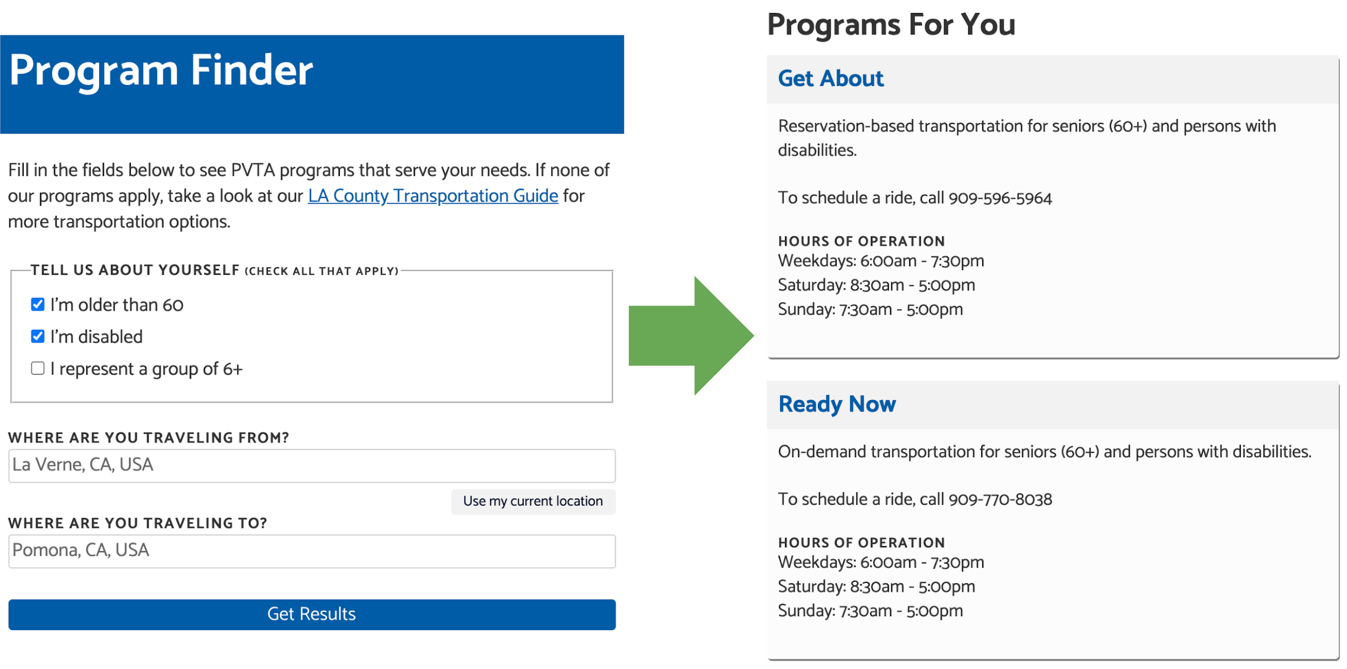
PVTA Program Finder with example results

Mapping service areas
The geographical data GTFS-flex produces can offer insight into the outcomes of a demand response program as well. For example, by using GTFS-flex’s geographical data, agencies and other stakeholders can map demand response service areas to measure access or to compare other transportation providers like taxis or TNCs.
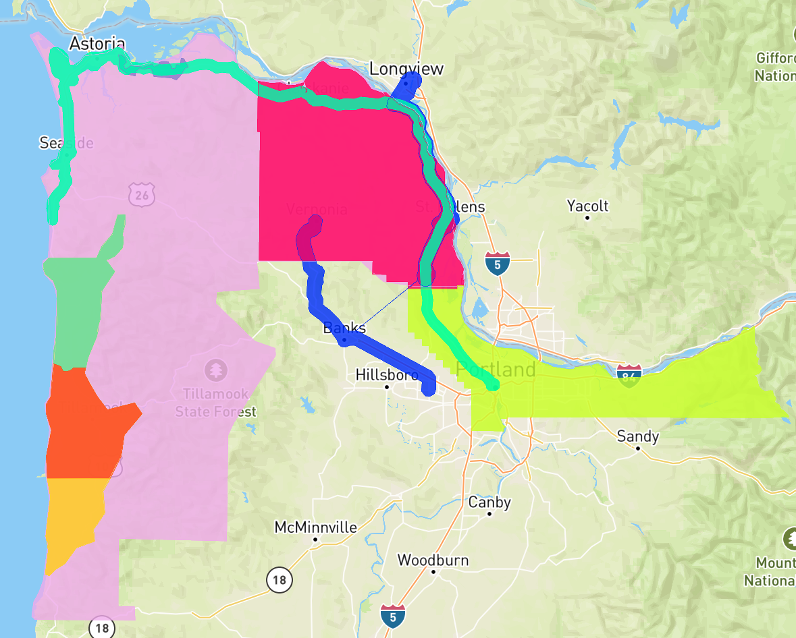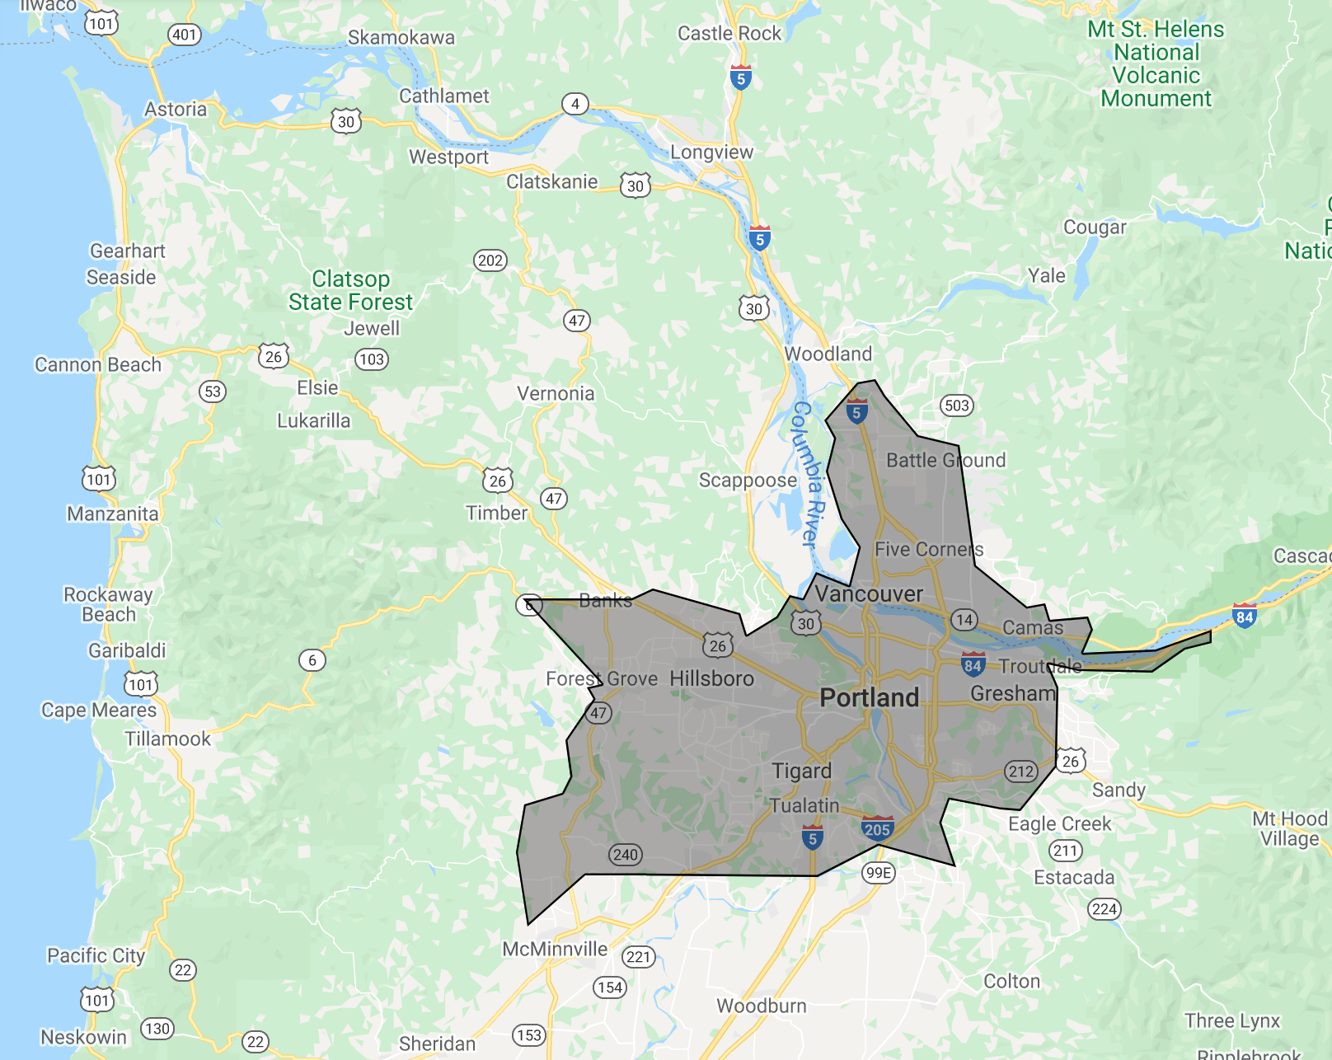
Various flexible services (excluding TriMet) of Northwest Oregon mapped with GTFS-flex (left) compared to closest Lyft service area (right).

Considerations for booking and real-time
Booking is an integral part of demand response transportation and other flexible services. Real-time information on service availability is of similar value to riders. GTFS-flex has not yet reached a point in its development to address booking (whether it is in-app or through deeplinks) or real-time, but is designed with space to meet these needs in the future.

Just as GTFS-Realtime exists as a separate specification complementing GTFS, a “GTFS-flex-Realtime” specification could reference GTFS-flex identifiers to provide trip planners with real-time information. An effort has been underway within conversations at MobilityData in late 2020 to define a “General On-Demand Feed Specification,” or GOFS, which broadly aligns with the use cases for a real-time extension of GTFS-flex. Although far from certain, it is not outside the realm of possibility that a significant attempt at real-time reservation standardization, sponsored by a major state or private entity, happens during 2021.

How does GTFS-flex work?
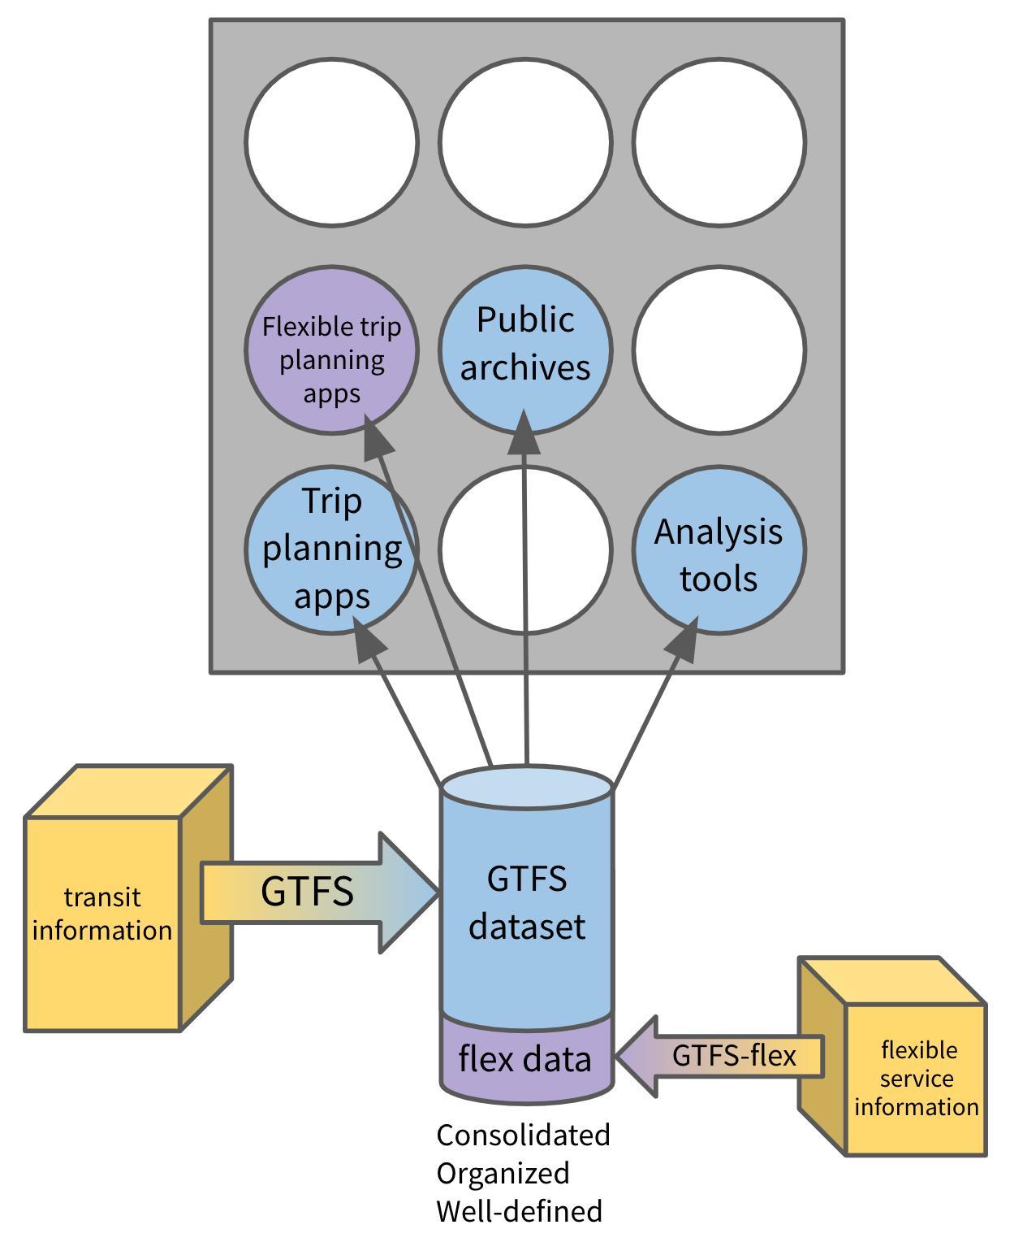
Diagram illustrating the mechanics of GTFS/GTFS-flex data consolidation and distribution

To understand how the flex extension works, it is important to first understand the basic structure of GTFS. GTFS packages a transit agency’s schedule, geographical, and fare information into a well-defined dataset, making it easy for entities like Google to consume and publish. The technology behind this data specification is simple: GTFS organizes transit data into rows and columns within a set of categorized, machine-readable .txt files. It is also spreadsheet-compatible, simplifying the process of viewing and editing the data “by hand.” For example, the stops.txt file of a GTFS dataset contains information on a transit system’s stops, such as their name, public-facing code, and latitude/longitude coordinates. For reference, a portion of TriMet’s stops.txt file is shown here in both a text editor application (above) and a text-to-columns spreadsheet (below). Each piece of information relating to a stop has its place under distinct categories. If a transit agency has moved a stop’s location, they need only to edit the stop's latitude/longitude pair in the stops.txt file to match the new location.
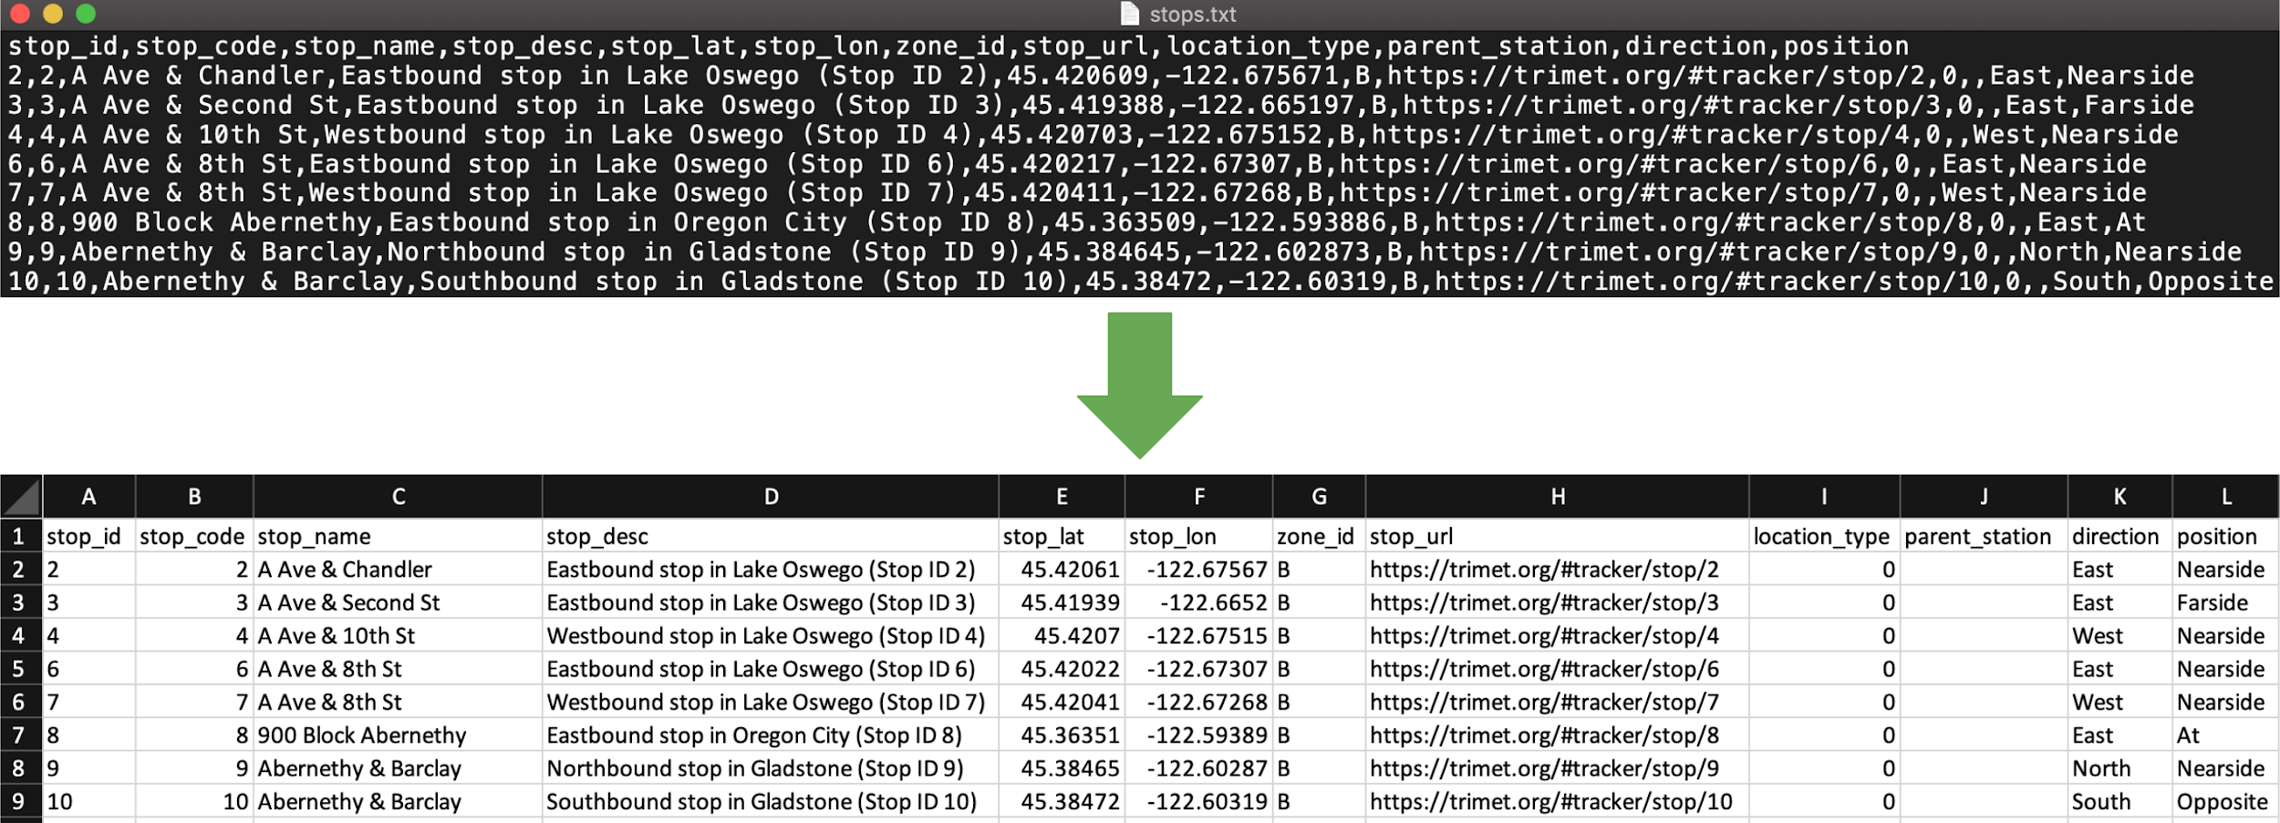
stops.txt file from TriMet’s GTFS dataset

GTFS-flex is similarly straightforward. As an extension of GTFS, GTFS-flex is expressed as additional files and columns within a GTFS dataset. GTFS-flex represents flexible transit services by incorporating information such as:
- service areas (for services where a vehicle can pick up and drop off a rider anywhere within a defined area)
- service hours (for services that operate within a timeframe rather than at specific stops at specific times), and
- booking rules (for services that require riders to schedule a ride).
The following table details the most salient changes flex v2.1 makes to the core GTFS specification.

Flex additions to GTFS | Description
New file: locations.geojson | GTFS-flex includes a GeoJSON file that defines polygons for the geographic areas in which demand response services can pick up and drop off riders.
New file: location_groups.txt | This defines multiple pickup/drop-off areas related to a single service.
New file: booking_rules.txt | This establishes whether a service has reservation requirements and provides booking directions. Specific data points include:  - minimum/maximum notice before scheduling a ride  - messages to convey general rules (e.g. where to stand when flagging a bus for continuous stopping service)  - booking phone numbers  - information or booking URLs
Modified file: stop_times.txt | Fields are added to stop_times.txt that describe:  - which areas from locations.geojson or radii apply to specific services  - where along a route continuous pickups and/or drop-offs occur  - time ranges in which a rider can be picked up or dropped off  - demand response travel time estimate adjustments
Modified file: trips.txt | Fields are added to trips.txt to account for:  - which booking rules apply to which services

The following is a hypothetical example of how GTFS-flex incorporates loose service information. In this example, High Valley Transit’s website includes a message describing how their demand response transportation service operates, from which specific pieces of information are pulled into sections of a GTFS-flex dataset.

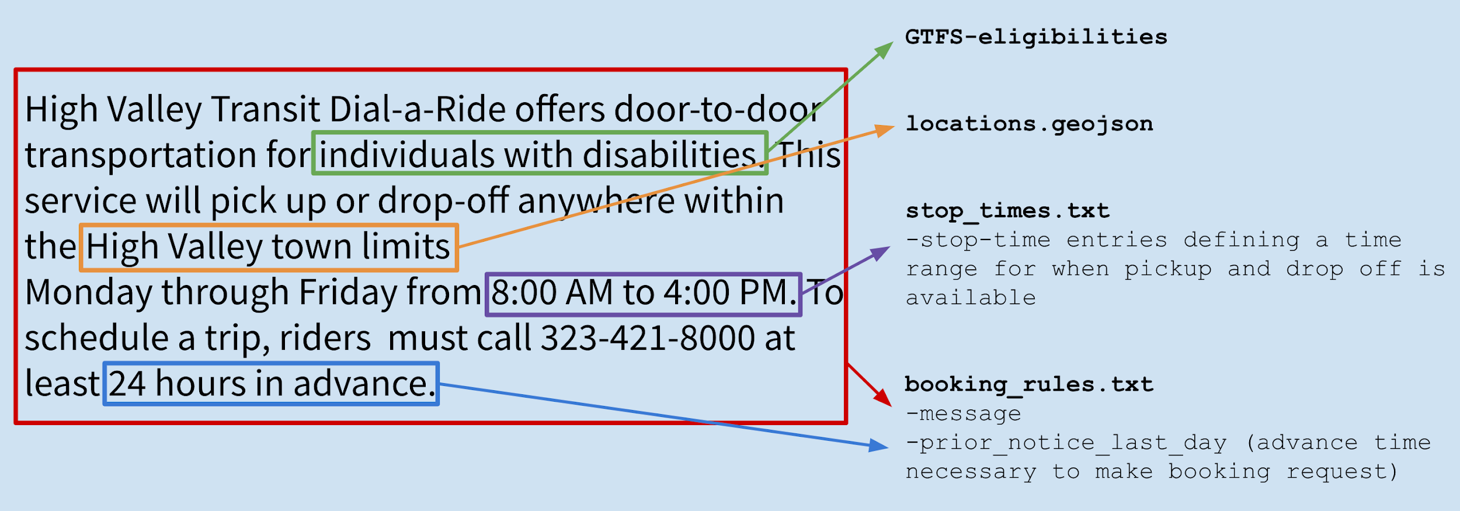
Distribution of a hypothetical agency’s service information within GTFS-flex

There are two points to remember regarding GTFS-flex’s design: First, GTFS-flex adds to rather than changes GTFS. A GTFS-flex dataset is identical to a GTFS dataset in every way but for the extra fields and files that define an agency’s flexible services. Second, as an extension, GTFS-flex is as simple as its parent specification, GTFS. This means that adding flexible data to an existing GTFS feed or building a new GTFS feed with flexible data included from the start are both manageable and familiar processes.
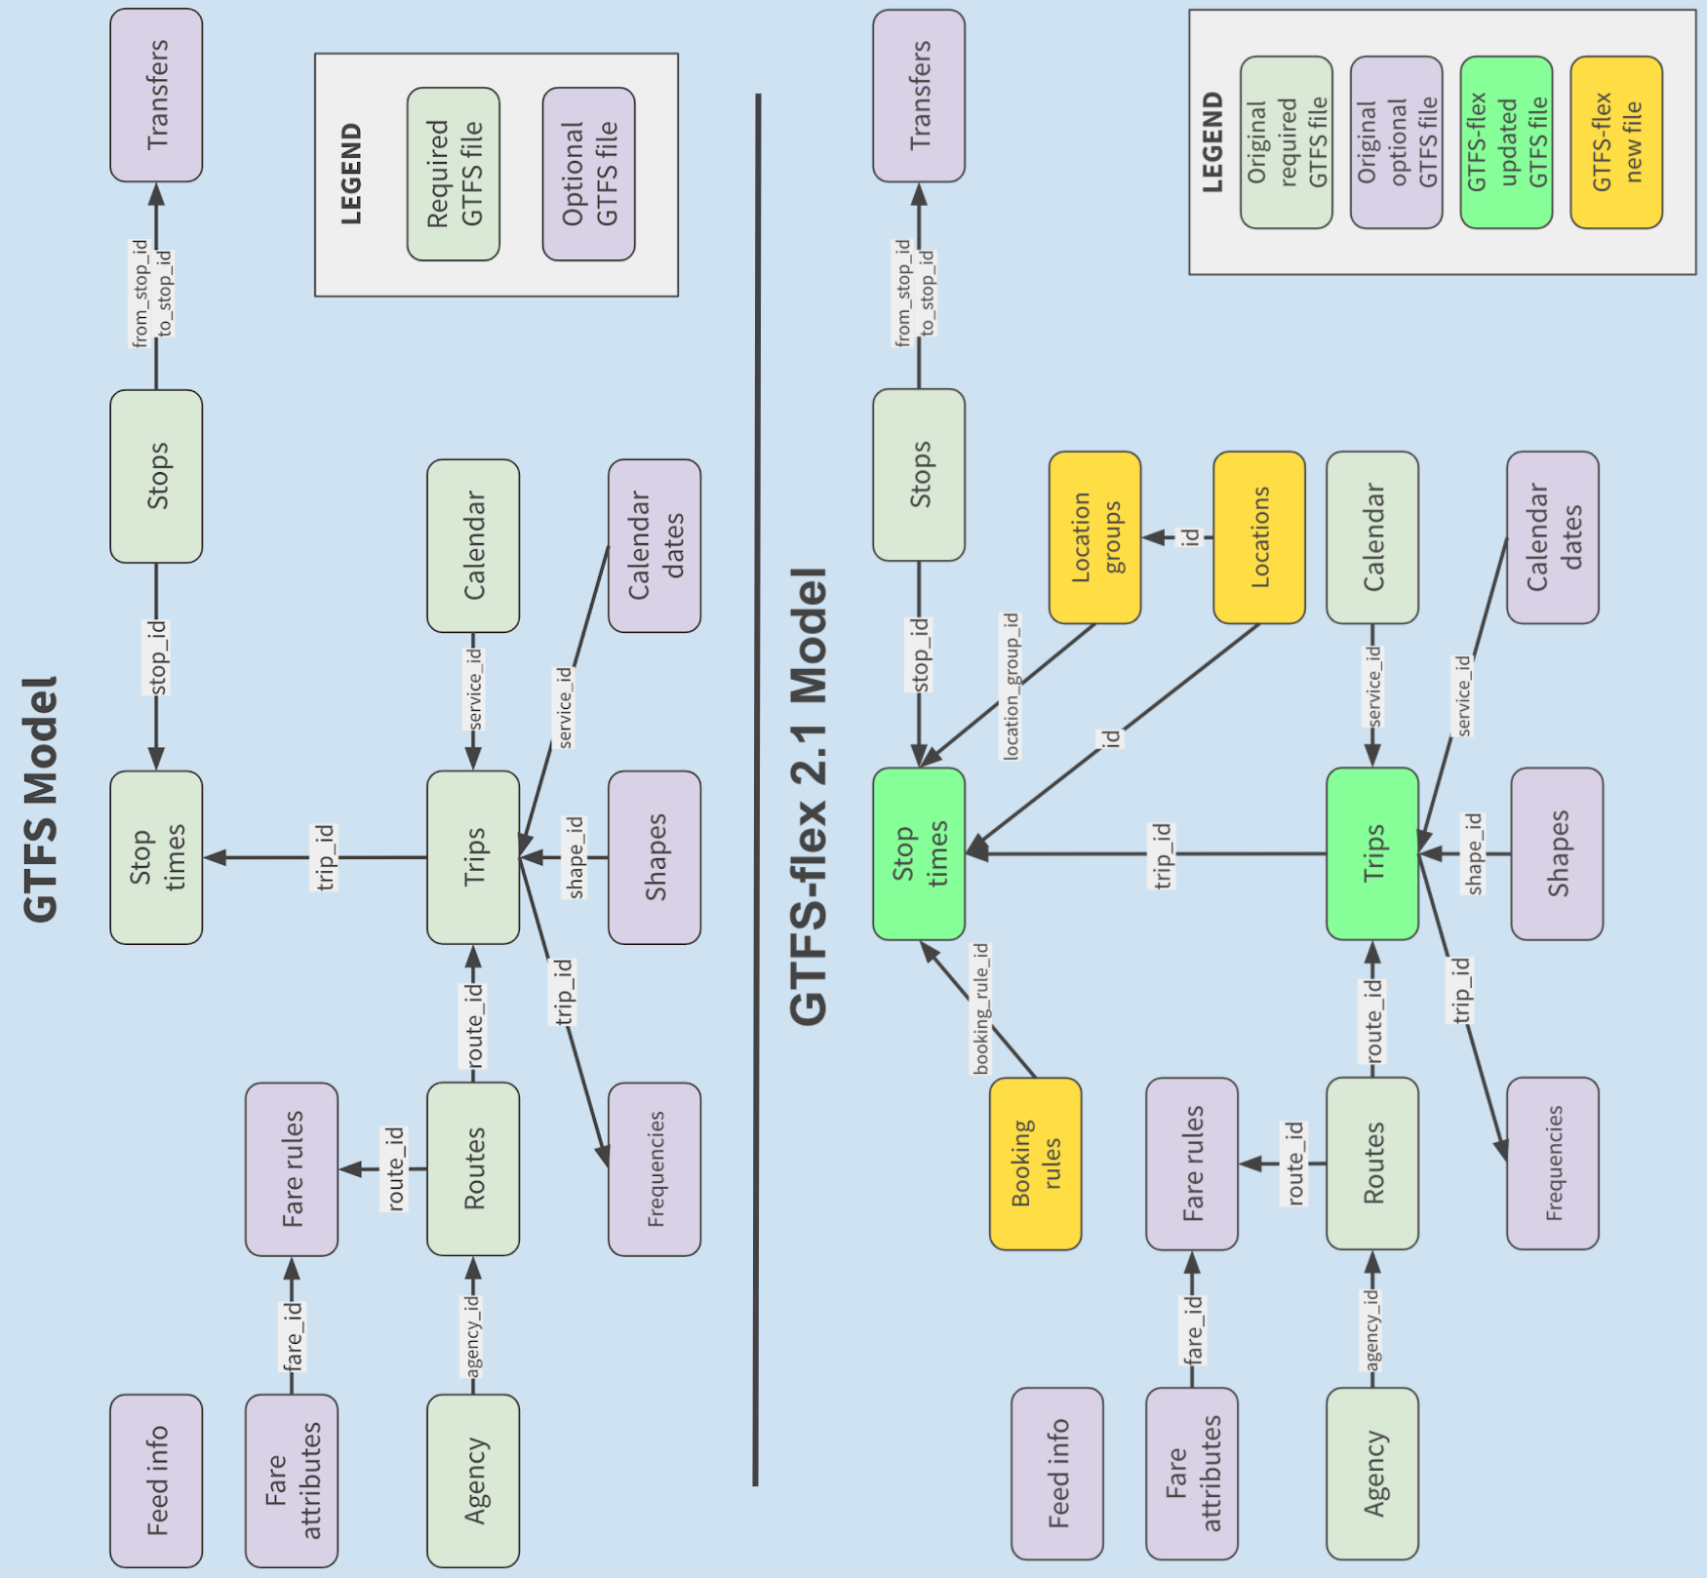
GTFS and GTFS-flex 2.1 schema diagrams

How did GTFS-flex originate?
The extension’s initial proposal was written in 2013 by Google software developer Brian Ferris to improve the modeling of flexible transit systems within the GTFS ecosystem. Collaborators such as Sean Barbeau from the University of Southern Florida, Ross Peterson of CR Peterson Consulting, and Aaron Antrim of Trillium later helped build upon Ferris’s initial proposal.

Subsequent investments detailed below have turned GTFS-flex from an idea into an operational and mature technology. While GTFS-flex’s development is ongoing, the extension will likely be fully adopted into the GTFS data specification within the coming year. One component, continuous stops, has already been officially adopted.

Mobility on Demand (MOD) Sandbox Program
The first major step in GTFS-flex’s development came in 2017 with the beginning of the MOD Sandbox Project, funded by the Federal Transit Administration (FTA). The Vermont DOT was funded under the Sandbox Program to develop the first large-scale GTFS-flex trip planning tool—using the OpenTripPlanner (OTP) web application—for all agencies in the state of Vermont. This required upgrading OTP to read flex data and include trip results for services like dial-a-ride, route deviations, and continuous stops. Trillium and Cambridge Systematics released the code developed for Vermont Agency of Transportation as open-source, integrated it into OpenTripPlanner v1.4, and have commercialized it along with Kyyti and Interline—other independent for-profit companies.

MobilityData stewardship
While the MOD Sandbox Project solidified GTFS-flex v1 as a well-established standard, stakeholders recognized the importance of the extension’s continued improvement. In 2018, MobilityData IO, a nonprofit that facilitates development and stakeholder engagement on several mobility data standards, assumed a leadership role for GTFS-flex and began development of GTFS-flex v2, which was released in 2018. Further refinements led to a version “2.1,” the current candidate for adoption, released in 2020.

OpenTripPlanner development
Since GTFS-flex’s inception, OTP leadership has worked to accommodate GTFS-flex in the development of their own software, one example being the MOD Sandbox Project. This cooperation established OTP as the major trip planning environment where GTFS-flex has been applied historically. Created in 2009 as an open-source web application, OTP’s malleability has also allowed developers to tailor the application to their own trip planning tools’ needs.

Since the release of version 1.4, OTP’s project leadership committee has focused on developing OTP2, which was released in September 2020 and ingests GTFS-flex 2.1 data to provide flexible trip plans. The upgraded routing technology in OTP2 provides significantly faster trip plans and improves how flexible and fixed-route services are combined in trip options.

How is GTFS-flex used today?
2020 has been the most active year of new GTFS-flex data deployments so far, with GTFS-flex data now produced for over 100 public transit agencies, mainly in the U.S., and utilized by at least six private companies (including Google, partially). Although European users did not initially adopt GTFS-flex v1, GTFS-flex v2 is now considered more viable and has seen some acceptance in Europe. Here, we provide a survey of projects utilizing GTFS-flex and highlight some companies providing GTFS-flex-based services.

Northwest Oregon Transit Alliance (NW Connector)
The Northwest Oregon Transit Alliance—a coalition of five agencies in Northwestern Oregon—wanted a trip planner that met the following specific regional needs:
- Intercity planning for trips to/from Portland
- Preference for public transit options rather than private carriers
- Representation of demand response services including dial-a-ride and deviated-fixed services
- Custom branding to promote the NW Connector service and the regional network provided by the agencies

The standard Google trip planner widget available on many transit agency websites did not meet these needs; OTP did by offering the ability to build a custom system to address each requirement.

Through a project funded by an Oregon Department of Transportation grant, the nwconnector.org website was refined to include a new trip planner that included these features. Because all five agencies in the coalition offer ADA paratransit, and at least some additional form of flexible service, the trip planner provided new transportation options for all riders using the website. Currently, a third party contractor hosts the trip planner software. In the future, however, NWOTA agencies are seeking to reduce the cost of the custom software set up by partnering with other regional agencies, or with ODOT, which hosts its own OTP software.
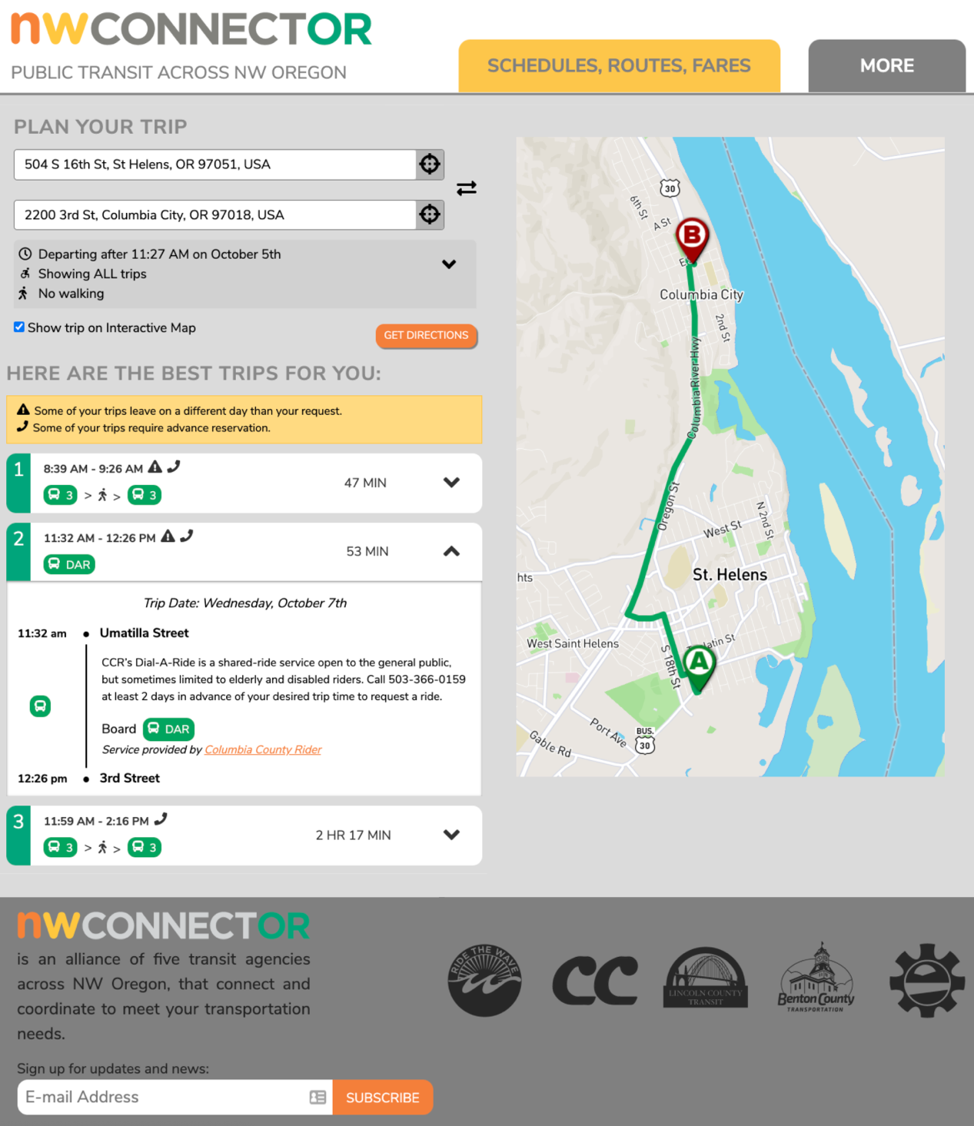
NWconnector.org trip planning page

Vamos Mobility
The Vamos Mobility app is a developing Mobility-as-a-Service platform that includes flexible transit trip planning and (in process) payment integration. The app is funded through a California Air Resources Board grant and a contract between UC Davis and DemandTrans (with Trillium as a subcontractor). Vamos is a combination of agency-owned GTFS and GTFS-flex data, an OTP instance hosted by a third party, and the Kyyti mobile application licensed and branded for the local region of San Joaquin and Stanislaus Counties in California. 12 agencies participate in the project, providing a mix of fixed-route only, demand response only, or both.

The Vamos project received an Integrated Mobility Initiative grant from the FTA to add payment integration for fixed-route services; payment integration for the demand response services is also under consideration. The Kyyti app technology provides account-based features that are not as available through simpler website-based apps like the NW Connector trip planner. With the Kyyti app, users can save favorite trips and account details, including payment information to streamline purchasing tickets.
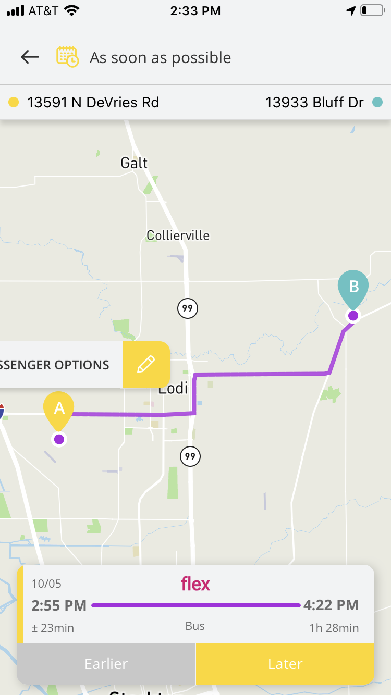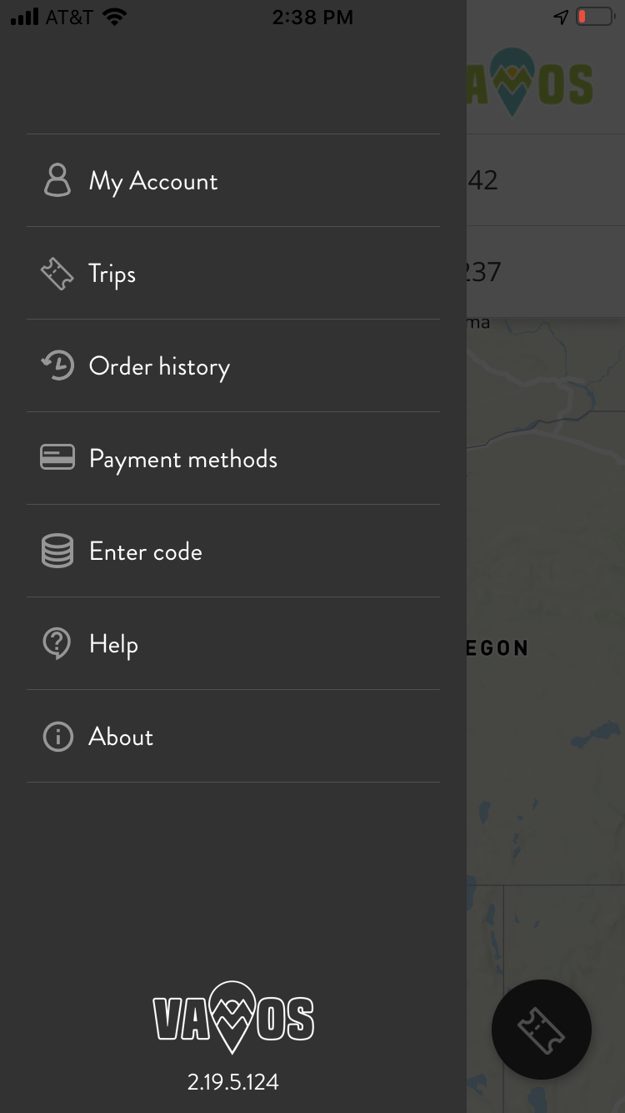
Vamos Mobility app

Denver RTD
Denver Regional Transportation District operates FlexRide services, which provide critical first-last-mile and accessible connections to the fixed route network. Denver RTD has been testing and developing GTFS data since 2017 and has focused in 2020 on operationalizing this technology for riders. The agency expects to release a GTFS-flex and OpenTripPlanner-based multimodal trip planner before the end of 2020.

Google Maps
While Google Maps does not yet include dial-a-ride or any other reservation-based services (apart from Uber and Lyft in select markets), Google has researched GTFS-flex and launched a new integration of one GTFS-flex component, continuous stops. GTFS-ContinuousStops was officially adopted in early 2020, which describes fixed-route services that allow riders to “flag down” a bus between stops (if there are stops at all). Google Maps now allows agencies to opt-in to provide this information through their GTFS datasets. More information is included in the section “What should I do with GTFS-flex” below.

GTFS-flex Vendors
There is a small but growing field of software vendors that produce or consume GTFS-flex data. An overview of these services is below (vendors utilizing GTFS-flex should email thomas@trilliumtransit.com to be included in future updates to this White Paper).

GTFS-flex v2 producers
- DemandTrans
- Trillium
- National RTAP (Continuous stops, with other features under consideration)
- IBI Group (coming Q1 2021)

GTFS-flex v2 consumers
- OpenTripPlanner version 2 (code development by Kyyti with other knowledgeable developers including IBI Group, Cambridge Systematics, and Interline)

What should I do with GTFS-flex?
GTFS-flex is a new and developing technology that has seen increased interest in recent years. Many improvements have been made in the software applications that produce and consume GTFS-flex, but we have yet to see a simple, affordable, and effective GTFS-flex-based product that any demand response agency can buy and immediately benefit from. However, there are some near-term opportunities for agencies and regions to leverage, which offer clear pay-offs, but like all technologies, have limitations.

Projects for 2020 and 2021

Flag Stops in Google Maps
Google Maps adopted the “Continuous Stops” extension to GTFS, originally part of GTFS-flex v1, early in 2020, just before the fields comprising this extension were officially adopted into the GTFS data specification. Google’s use of this data allows riders to see trip plans that begin or end at any intersection along the shape of the route in the Google trip planner.

Flag stops, as this behavior is often known, are easily represented in GTFS by the addition of two columns to either stop_times.txt or routes.txt. These columns contain codes indicating whether flag stops are allowed along the shape after each stop in the route. National RTAP and Trillium both support this feature for all their users, and any agencies maintaining GTFS via spreadsheets could easily add this information as well. Those using other systems could inquire with their vendors.

Below is an example of two flag stop trip plans in Google Maps. Each has a different destination but use the same transit route. One caveat worth noting is that although properly signified in the data, Google Maps does not mention that drivers expect a rider to signal for a pickup.

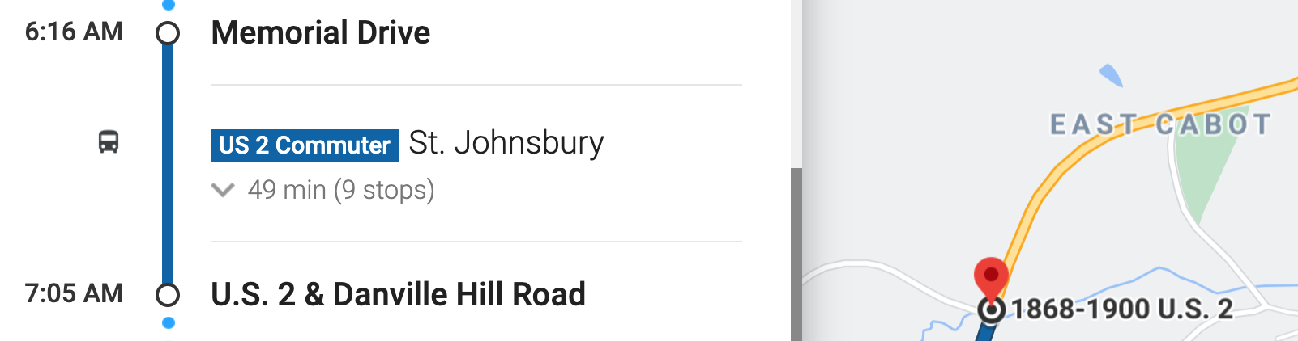
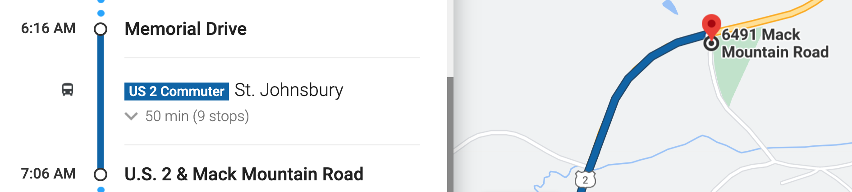
Flag stops in Google Maps

Regional Flexible Trip Planners
A multimodal flexible trip planner like ridetcat.org or nwconnector.org is achievable, but there are a variety of products available with a wide range of prices and functionalities. Additionally, while all of the technology required is open-source, it is also complex and not easily deployed without experienced developers; even if a small, rural agency wanted to create such a tool in-house, they likely would not have the internal capacity to build and maintain it on their own.

Agencies can overcome these barriers in the near term by partnering with other regional providers to launch a multi-agency flexible trip planner. Creating these tools is more feasible as a regional effort with five or more providers (like nwconnector.org), especially since the region is also likely to have some funding already pooled for technology projects. A regional trip planner can also serve as the foundation for a “Mobility-as-a-Service” platform in which individual agency websites and other systems can leverage the trip planner results at little or no increased cost.

Directories and Website Integration
DOTs or other organizations can implement large-scale imports of GTFS-flex datasets into a single database for comparative analysis of demand response services or for extracting specific details of those services. One example of this use is the Oregon DOT’s development of an open-source transit agency directory platform, recently funded by an FTA Accelerating Mobility Initiative grant. A complete list of demand response services (powered by GTFS-flex and GTFS-ride data) that includes critical information like hours and areas of operations could support ancillary DOT objectives. Directories could also serve as starting points for future demand response trip planning if and when other apps begin consuming GTFS-flex.

Request in “MaaS” or “Microtransit” Projects
Academic, business, and agency organizations have consistently worked together for years to drive the development and adoption of GTFS-flex because we believe that the specification presents an opportunity for community transportation to compete. Transportation network companies have the privilege to buy ads in Google Maps and appear as first/last mile connections in “MaaS” apps. Small public agencies should be able to compete on a level playing field with TNCs; they should have access to the same technologies that microtransit operators do without the need to use operators’ proprietary apps.

GTFS-flex describes any flexible shared-ride service—even a taxi, Uber, Lyft, or microtransit service. If an agency is considering a pilot for this type of service, requiring a GTFS-flex dataset as a condition of the pilot would ensure the service is ready to integrate into future trip planning apps.

GTFS-flex in the Future
Two requirements must be met before GTFS-flex or any proposed addition is fully adopted into the core GTFS standard: First, there must be a data-producing system and a data-consuming system that utilizes the proposed extension. Second, the addition must be approved in a vote held by the GTFS community. These conditions will likely be fulfilled for GTFS-flex by the end of 2020, making GTFS-flex an official part of the GTFS data specification.

Regardless of whether that happens, further enhancements are planned. However, because most development of new features for GTFS-flex and related technologies relies on grant funding, it is difficult to predict the exact timeline to some important features which are highlighted here.

Reservations and Real-Time Booking
The user experience in today’s flexible trip planners is incomplete without reservation and booking capabilities. Users trip planning for a demand response service would be justified in questioning the counterintuitive step requiring them to call the agency to book instead of directly booking through the tool.

The GTFS-flex community recognizes this deficit and the functionality that solving it would add; the GOFS, or GTFS-Flex-Realtime, effort is thus underway, although it is also far from becoming useful to transit agencies.

Brokerages and Sharing Trips
The exchange of information between a trip planner and a reservation system provides for booking a customer trip, but in practice, operations are not performed consistently by one agency. Community transportation operators commonly share riders between services, so the reservation systems should also communicate with other reservation systems and with brokerages. This issue has seen important development and the beginning of standardization through the TCRP G-16 project.

A More Competitive and Equitable Market
The vision of GTFS-flex is a more competitive and equitable market where no single operator or software vendor owns the entire customer interaction and where all riders see all options, including the ones best for them. Actualizing this vision will require adoption by both existing and new vendors in the marketplace and further education of agencies and regulators, which takes time and investment. Fixed-route transit has already undergone these processes: Large urban agencies can depend on Google Maps or the Transit app, and if their CAD/AVL system does not deliver, they can switch with minimal disruption to riders. But this was not the case for fixed-route agencies a few years ago. GTFS and GTFS-Realtime, which required their own time and investments, helped fixed-route transit arrive at the place it is today; GTFS-flex may yet do the same for flexible transit.

American Public Transit Association. (2019). 2019 Public Transportation Fact Book, 7. Retrieved from https://www.apta.com/wp-content/uploads/APTA_Fact-Book-2019_FINAL.pdf
Americans with Disabilities Act of 1990, 49 CFR §37.121.
In GTFS, “continuous stops” refers to services that allow riders to board and/or alight at any point along a route other than fixed stops. This is separate from “flag stops,” which GTFS defines as fixed stops where riders must “flag down” the vehicle to be picked up.
Eligibility requirements were originally included in GTFS-flex v1, but are now represented more robustly in a separate extension, GTFS-Eligibilities. While GTFS-flex v2.1 excludes details on eligibility, it remains an integral piece of the flex ecosystem given its close relationship with flexible services like paratransit.
Google Maps currently only integrates the continuous stops feature of GTFS-flex.
See below, page 13
Gtfs.org has more detailed information on the specification.
GeoJSON is a human-readable open data format that produces geographic data structures.
This file replaced the areas.txt file in GTFS-flex v2, which used the well-known text (WKT) format to define polygons.
The original GTFS-flex proposal can be found at https://docs.google.com/document/d/1UTcpMJlANSoJ1ZEk5IrQh_plza1ZnvgwraMEBI_o2mw/edit#heading=h.b0kuau2fzob8
The Vermont Agency of Transportation MOD Sandbox report can be found at https://www.transit.dot.gov/sites/fta.dot.gov/files/docs/research-innovation/146891/fta-report-no-0150.pdf
https://mobilitydata.org/
OTP2 has launched as a release candidate, but has not yet been released as a final, new version. Release candidate and documentation can be found at http://docs.opentripplanner.org/en/2.0-rc/
Code for OTP2 flex features can be found at https://github.com/opentripplanner/OpenTripPlanner/tree/dev-2.x/src/ext/java/org/opentripplanner/ext/flex
Interline, subcontracted through Trillium
https://vamosmobility.com
https://www.rtd-denver.com/services/flexride
https://github.com/google/transit/pull/208
Any vendors who wish to be added to this sentence may email thomas@trilliumtransit.com.
Test it out here.
https://www.transit.dot.gov/research-innovation/fy20-accelerating-innovative-mobility-aim-project-selections
Ridership specification proposed by Oregon Department of Transportation and Oregon State University. gtfs-ride.org
OpenTripPlanner will operate as the data consumer with Trillium serving as the data producer for the required implementation roles, but a vote of the GTFS community will be required.
https://apps.trb.org/cmsfeed/TRBNetProjectDisplay.asp?ProjectID=4120

