Prepared by:

Kevin Chambers
Lara Bjork
Twitter: @TransitNCATT
Website: n-catt.org
Facebook: @TransitNCATT

A Framework for Making Successful Technology Decisions

October 23, 2020
About N-CATT
The National Center for Applied Transit Technology (N-CATT) is a technical assistance center funded through a cooperative agreement with the United States Department of Transportation’s Federal Transit Administration (FTA). Operated by the Community Transportation Association of America (CTAA), the mission of N-CATT is to provide small-urban, rural and tribal transit agencies with practical, replicable resources that help them apply technological solutions and innovations. Among its activities, N-CATT produces a series of white papers, technical reports such as this document, and other resources, all of which can be accessed on-line at https://n-catt.org.
About this Document
This document was prepared for CTAA by the Center for Transportation and the Environment (CTE) in September 2020 as part of the N-CATT cooperative agreement between CTAA and FTA. Primary authors were Kevin Chambers and Lara Bjork of Full Path Transit Technology. Opinions expressed or implied in this document are those of the authors. Nothing in this document is to be interpreted as position, policy or guidance from the United States Government. Incidental use of companies' names or the names of their products is made solely to facilitate discussion and should not be regarded as recommendations or endorsements.

Acknowledgements
We are grateful to all of the rural, tribal, and small-urban transit agencies and transportation providers who deliver mobility and dignity for their riders. We are especially thankful for your willingness to share your experiences (good or bad) with technology. We hope this white paper helps make your jobs easier. The following leaders in transit and transit technology provided valuable context on the state of the field:
- Josh Andrews, Co-founder and Chief Operating Officer, Spare Labs, Vancouver, BC
- Robert Betts, Director of Operations and Planning, Marin Transit, San Rafael, CA
- Thomas Craig, Chief Executive Officer, Trillium Solutions, Portland, OR
- Alex Fay, Chief Commercial Officer, GMV Syncromatics, Los Angeles, CA
- Jacklyn Montgomery, Executive Director, CalACT, Sacramento, CA
- Michelle Poyourow, Principal Associate, Jarrett Walker + Associates, Portland, OR
- Daniel Quirk, Director of Information Technology, Hopelink, Bellevue, WA
- Doug Spears, Vice President, Ecolane, Helsinki, Finland
- Paige West, Planning and Strategic Programs Manager, Rogue Valley Transportation District, Medford, OR

Table of Contents
A Framework for Making Successful Technology Decisions 1
Acknowledgements 3
Introduction 5
The Dream 5
The Reality 6
Key Terms 7
Transit: Define What It Is for Your Agency and Community 7
Technology: What It Is and Where It Fits 8
Core Concepts 9
Capacity Building 9
Systems Thinking 10
Design Thinking 11
Systems Engineering 11
The Steps 12
Phase 1: Define and Rank Problems 13
Cast a Wide Net to Identify Pain Points 14
What Your Problem Statements Should Cover 15
Ranking Problems by Risk 17
Phase 2: Develop Potential Solutions 18
Assemble Your Team(s) 18
Understand Your Systems 19
Build Knowledge by Casting an Even Wider Net 20
Set Priorities 23
Comparing Your Options 24
Term to Know: Software as a Service 27
Phase 3: Procuring 30
Phase 4: Implementation and Maintenance 31
Conclusion 32

A Framework for Making Successful Technology Decisions

Introduction
Transportation-related technology is a rapidly changing marketplace. It’s hard to stay up to date on the available options, understand how well they actually work, and be confident that your organization has what it needs to implement them successfully. If you work for a rural, tribal, or small-urban transit or transportation provider, making decisions about new technology might be something you dread. This white paper aims to help you change your viewpoint by offering a framework for successfully articulating your operational needs, assessing whether technology can be part of a solution to them, and evaluating options—especially if you don’t have an in-house IT department.
The focus of this white paper: electronic- and information-based systems that are being adopted now, are quickly developing, or are not really on the market yet, while keeping in mind that technology should allow an agency to do more at a larger scale in a way that supports the agency mission.
By making good technology decisions, we want to end up with a set of systems that support and make transit either more efficient, more usable, or, ideally, both. Making decisions about when to add, remove, or update any technology can be daunting, but there are ways to make it more successful in the long run.

The Dream
We wish technology were easy—that we lived in a world where the tools lined up just right with the way we work and the way we think. In such a world, solving a technology problem is akin to replacing a broken light bulb. The solution is pretty straightforward: you need a new light bulb.
Because there are different types of light bulbs, you do some research on each type’s costs and benefits, thinking about factors like purchase price, lifespan, operating costs, and environmental impact.
Next, you analyze all the possible solutions, select the one that's the best for you, and move forward with procuring the light bulb. You look at the different vendors that provide that specific version of the option that you've chosen. You do a cost-benefit analysis of those vendors and select the one that is the best, according to the criteria that your procurement process has defined.
At last, you implement. You screw in the light bulb, flip the switch, and sit back, having completed a highly successful approach to solving yet another problem. You get to step away for months if not years before you ever have to think about that light bulb again. Rainbows flood your office, and unicorns are waiting for you in the parking lot!

The Reality
Of course, outside of buying actual light bulbs, things rarely go this way. The reasons may be obvious but it’s important to name them in order to address them one by one.
- System complexity. Transportation is complex. Services are complex. We’re not agencies devoted to replacing light bulbs. A closer analogy would be that we’re like electric companies responsible for managing an entire electrical grid. We’re juggling drivers, vehicles, schedules, and routes. It’s a lot to deal with.
- Misaligned expectations. The vast majority of us come into the world of transit technology with a set of preconceived notions about technology shaped by our experience with laptops, smartphones, and other consumer electronics. While some transit-specific technologies do approach the sort of plug-and-play experience we’ve come to expect from our mobile devices, it’s not the norm.
- An absence of standards. For significant aspects of transit, the truism of “if you’ve seen one transit agency, you’ve seen one transit agency” still holds true. The wide range of operations and systems behind them has only grown with the recent rise of Transportation Network Companies (TNCs), and other disruptive transportation models that have forced agencies to seek out tools that are too new to have a settled design approach. Yet even for hardware and software that have been mainstays in nearly every agency for many years, there is a constant battle with tools that are not designed to integrate into a larger ecosystem.
- An absence of leadership. The challenges of complexity, confusion, and incomplete tools get compounded by the hope that technology will lead the way and free us from making tough decisions.
For rural, tribal, or small-urban transit agencies, these challenges have an extra degree of difficulty. It’s unlikely that you have dedicated IT staff who have the time to devote to stay on top of the rapidly shifting landscape of technology options.

Key Terms
Before we go any further, it’s important to clearly define transit and technology. These concepts might seem so basic that it could be tempting to skip over them. However, taking the time to articulate your agency’s understanding of these elements will provide invaluable guidance throughout the decision-making process.

Transit: Define What It Is for Your Agency and Community
Take a minute to think about the priorities that guide your agency. Are you more focused on ridership (aka “moving the masses”)? Do you care most about coverage (that is, providing a minimum level of service to all community members)? Do you seek to balance the two considerations?
There’s no universally correct answer to these questions, and as much as we’d all like to see one, there’s no solution that optimizes both ridership and coverage 100% of the time. But there are answers specific to your community that provide indications of when your transit service is successful or not. Whether or not they are spelled out in your mission statement or strategic plan, your priorities are already evident in the ways that decisions are made about every aspect of your operations. If you don’t have clarity on what constitutes success for your service, take the time to document these priorities formally. Having this definition will help you make decisions more effectively, including ones about technology.

Technology: What It Is and Where It Fits
We use many items every day without a thought for how they came to be or what life was like before they existed. Over time, what was once a technological revolution becomes mundane—and possibly not even something we’d categorize as “technology”.
When technology is working as we expect, we barely notice it. Our frustrations often come from an expectation that “it should just work”, the “it” being almost anything digital, automated, or electronic.
Expecting technology to do what it’s meant to do isn’t unreasonable. Broadly speaking, technology is meant to help us, either by doing work faster or by doing more than we can do without it.
Before we add a new element of technology to our transit operations, we need to identify a more specific purpose. What are we going to be able to do more of because of this technology? What scale can we achieve if we use this technology? A train is useful to board only if it’s heading in the direction you want to go. Likewise, a piece of technology must achieve productivity or scale in a way that aligns with your mission, or it should be set aside. With that in mind, here’s a working definition of technology that we’ll use for this white paper:
A technology is a system designed to increase productivity or enable scaling in service of an overall mission.
Every single transit agency already employs technology that increases productivity in a scaled way in every community. What technology is this? Vehicles. Whether your fleet includes buses, sedans, cutaways, or other vehicle types, you are already successfully deploying technology to meet your mission.
The technology of transit vehicles is rapidly evolving, but vehicles aren’t the focus of this white paper. Instead, we will take a closer look at electronic- and information-based systems that are being adopted now, are quickly developing, or are not really on the market yet, keeping in mind that these systems should be chosen based on how well they support your service design and overall mission.
By making good technology decisions, we want to end up with a set of systems that support and make transit either more efficient, more usable, or, ideally, both. Making decisions about when to add, remove, or update any technology can be daunting, but there are ways to make it more successful in the long run.

Core Concepts
The framework for making technology decisions is built on two core concepts.
- Capacity building addresses the importance of empowering agencies to recognize they can be in the driver's seat with regard to technology.
- Systems thinking is essential to making solid organization-level decisions about technology.

Capacity Building
Long gone are the days when computing and automation of information were relegated to mainframes touched only by highly trained engineers. With supercomputers in nearly every pocket, the pervasiveness of information technology in our lives is one of the most striking characteristics of the modern era. Yet the tendency still persists today to segregate thinking about technology into roles filled by highly paid specialists, even as general understanding about how such things work has expanded tremendously and no one is left unimpacted by what's ultimately built.
Much of this continued reliance on “techies” can be attributed to the myriad details needed to get a given piece of technology to work and a pace of change that’s hard for the average person to keep up with. For that there will always be a need for people with expertise in a given technology domain. But when it comes to thinking about the role technology is to play in an organization, we urgently need a different approach if we are to increase the likelihood of success.
In this white paper, the framework for technology decision making proposes an “all hands on deck” approach, where perspectives are sought from everyone involved or impacted; everyone is assumed to have the capacity to think critically about technology; and no one needs to look or act like the stereotypical techie to actually be one or become one. This is especially important when it comes to smaller agencies, where a belief that technology is beyond their understanding blocks possibilities that may be critical to its success. Wherever skills that support managing technology are already present, they need to be recognized so they can be brought to bear. Where they can be developed internally through support, training, or hiring, that opportunity should be explored free from the preconceptions left over from the distant past.

Systems Thinking
As a steward of complex transportation infrastructure, you are responsible for seeing how many parts of that system relate to and affect each other. That means you’re engaging in systems thinking, which Daniel Kim has defined as “a school of thought that focuses on recognizing the interconnections between the parts of a system and synthesizing them into a unified view of the whole.” We encourage you to explore this topic , but for our purposes, we want to introduce the general idea of having a systems thinking mindset.
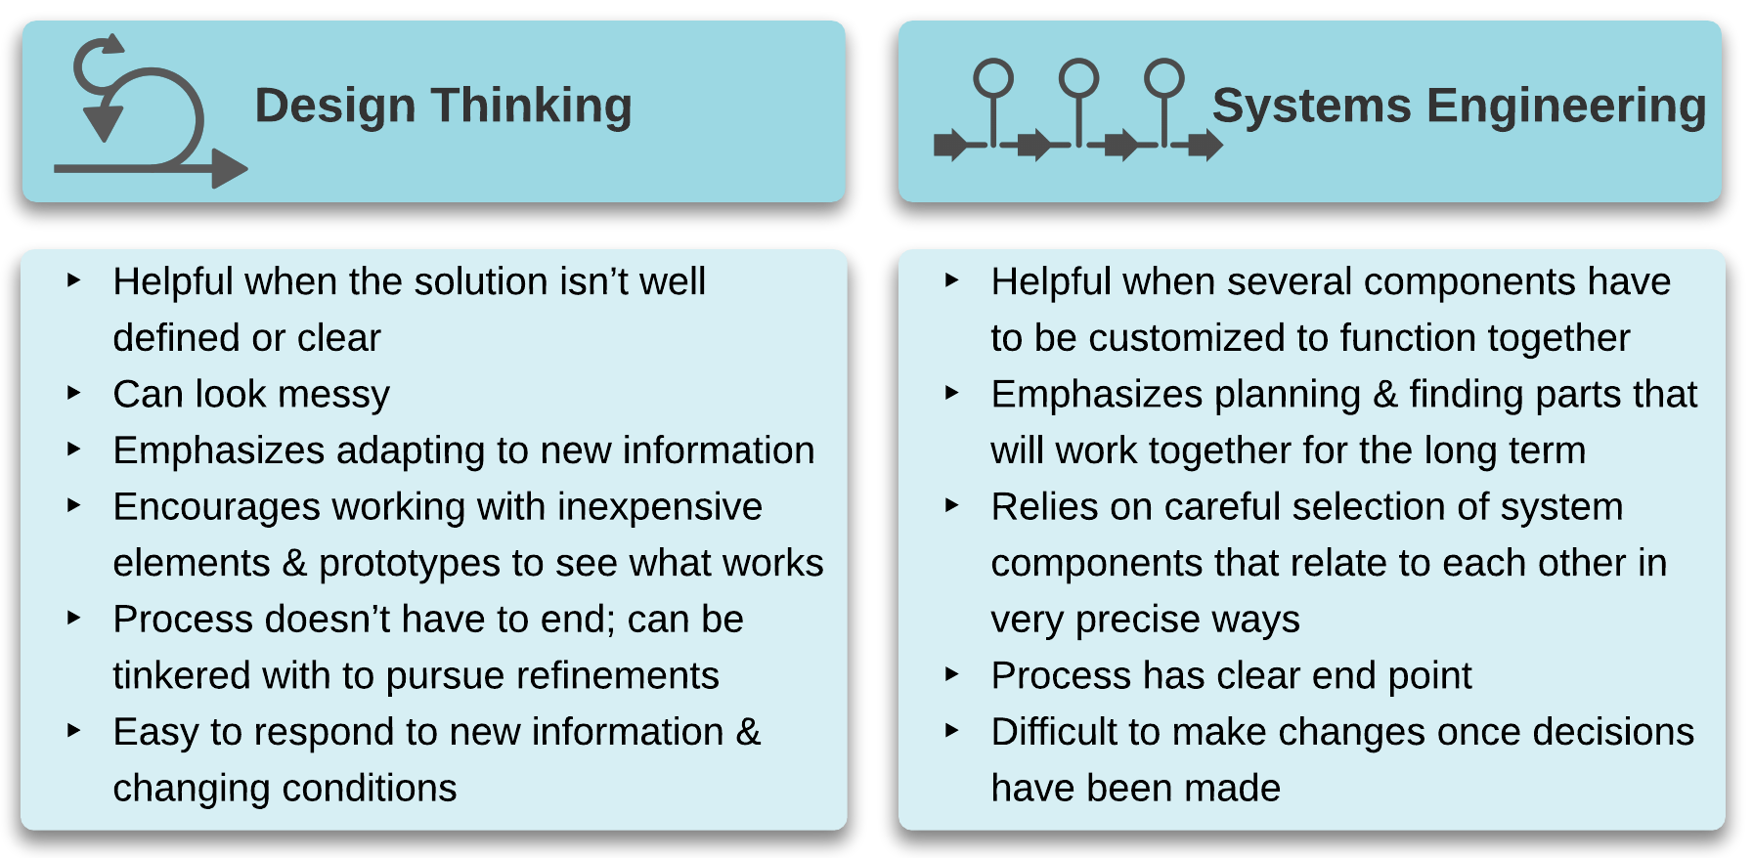
Figure 1. Differences between Design Thinking and Systems Engineering.
We’ve selected two complementary flavors of systems thinking: design thinking and systems engineering. Figure 1 provides an overview of these ideas. These two approaches can be used together or separately, depending on your needs. Later on, we’ll point out situations that lend themselves to one versus the other

Design Thinking
The Interaction Design Foundation describes design thinking as “a non-linear, iterative process that teams use to understand users, challenge assumptions, redefine problems and create innovative solutions to prototype and test.” Figure 2 shows the five phases or stages of design thinking: empathize, define, ideate, prototype, and test. A design thinking process is quite flexible, allowing teams to adapt to new information. Because of its emphasis on iteration—repeated questioning, generating of ideas, and cheap prototype testing—design thinking is useful in making technology decisions where there are many unknowns at the outset of the process. In the face of uncertainty (“we have a problem, but very little idea how to solve it”), design thinking permits an open-ended, exploratory approach that can help define a path forward. This type of thinking can be used throughout your decision-making process, on its own, or in conjunction with other methods, including systems engineering.
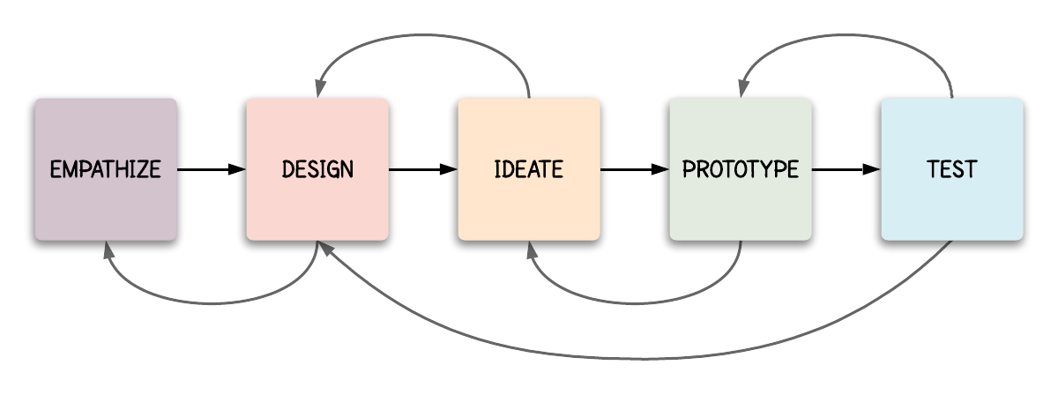
Figure 2. Stages in Design Thinking.

Systems Engineering
In contrast with design thinking, systems engineering is a more formal, linear process. Systems engineering requires significant time and effort, perhaps with a consultant, because it calls for a detailed articulation of all system requirements before you’ve settled on any specific solution. For complex technology projects, this process can save time and money in the long run because it demands thinking things through systematically. It tends to be the best approach when the end result is long-lasting infrastructure. As an intentionally linear process, backtracking when problems arise can be difficult.
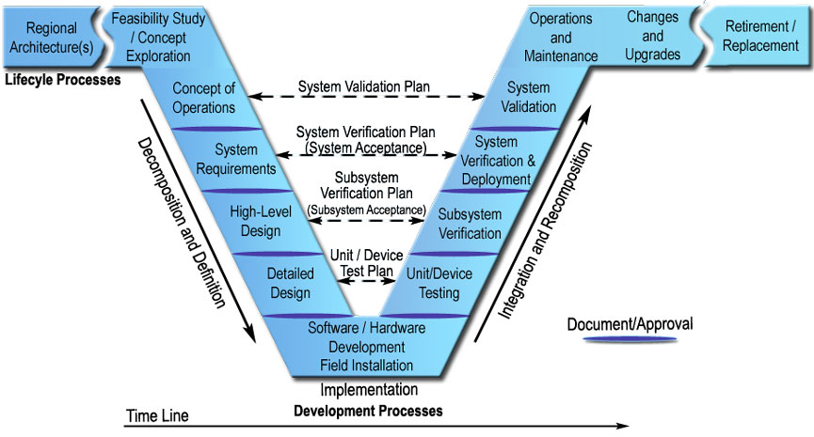
Figure 3. Systems Engineering’s “Vee” Design Emphasizes Testing and Validation.

The Steps
These two core concepts are carried through the full process of decision-making, using specific steps and tools to guide your team’s thinking. Whether using design thinking, systems engineering, or both, the intent of building your agency capacity is to increase your team members’ sense of ownership in the process and its success, think critically about solutions, and contribute to a complex project.

Specific steps for agency capacity-building consist of the following:
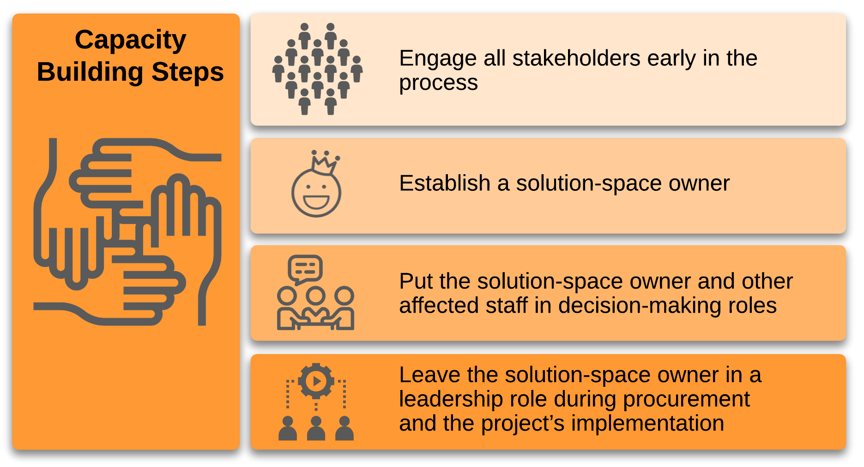
To ensure that your project maintains a systems-level view, these organizing tools can help everyone work in concert. It’s not necessary to use all of these tools every time, but it’s important to have them available to you and your team when they can help.
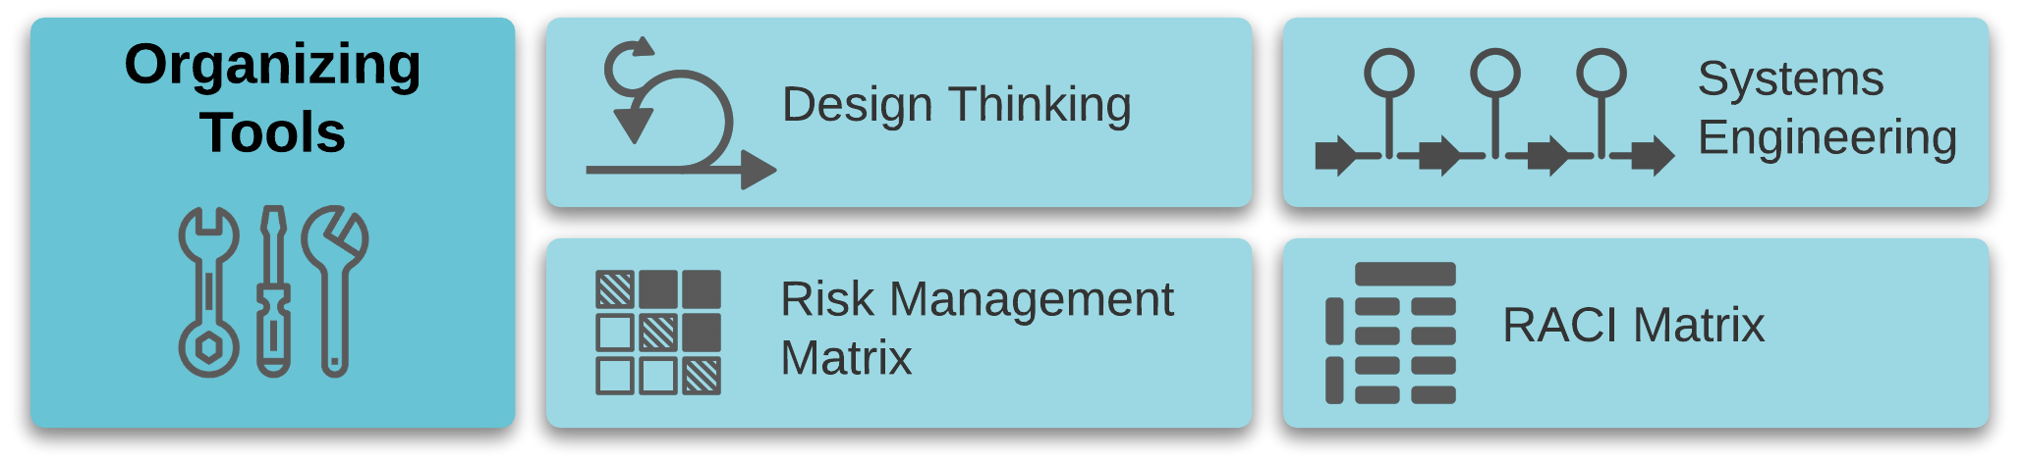

Phase 1: Define and Rank Problems
One of the hazards transit agencies face is that problems don’t present themselves as clearly as a burned-out light bulb does. You have to know what problem you’re trying to solve before you start solving it.
During this phase, start by making a list of pain points across your operations, whether or not they currently relate to an automated/electronic form of technology. People know what they don’t like, making it an easy entry point that keeps attention on unmet needs. There will be time to fully inventory all the technologies that you use later. As many people in the agency as feasible should contribute to this list. Pain points are essentially observations, and they don’t have to have a particular structure or format. You’ll take each observation and convert it to a problem statement, which is more targeted and must meet specific criteria. Finally, you’ll evaluate each problem statement based on the risks it presents. This phase borrows from the cybersecurity-focused work of the National Institute of Standards and Technology and others and applies it to today’s transit context.

Cast a Wide Net to Identify Pain Points
The first step in identifying what isn’t working is to cast a wide net. That means including as many people from as many parts of your organization as possible in conversations about pain points. Once a pain point is identified, it’s essential to gather information from the people most affected by it; you want to be able to evaluate the severity of the situation and fully define what the problem means throughout your operations. You may even decide to go outside your organization, to access someone else’s domain expertise and/or personal experience with your services. In this paper, we won’t prescribe who should be on your team, and for simplicity’s sake, we will speak in terms of “your organization” and “your staff”, although you may be working with external partners and stakeholders, too.
Questions you can ask include:
- How much time a week do you spend doing X?
- What do you think are some other ways we could accomplish this?

Capacity Building Step Number 1: Engage all stakeholders early in the process
Front-line staff may not be used to thinking about other ways to get a task done (although you may be surprised!). By asking questions about their experiences, you are not only gathering information and possible solutions, you’re also increasing your chances of success later on. This early engagement is the first step in the framework’s capacity-building process. It builds the foundation for staff becoming stakeholders who are invested in making the eventual solutions successful.
At this point, you are focused on making observations about what isn’t working well, without emphasizing solutions or broader implications.

What Your Problem Statements Should Cover
After gathering information from throughout your organization, it’s time to turn your list of pain points into a list of problem statements. Problem statements have two important qualities:
- Connected to service design. Problem statements are rooted in barriers to successful service delivery, referring back to your organizational definition of what successful transit looks like.
- Not prescriptive. A clear problem statement should leave you open to multiple solutions, rather than directing you immediately to a specific kind of technology purchase. An example of a preconceived solution lacking a clear problem statement is “We don’t have an app. We need an app.” Lack of a specific technology is not a problem statement. It’s an accurate observation, but it doesn’t tie into what we want to accomplish for riders.
When rewriting your pain point list into problem statements, check for considerations like the ones below. You should keep asking questions (these or your own) until you have a problem statement that can be directly connected to a technological issue that is getting in the way of achieving all or part of your mission.
Because of this problem, are we:
- Falling short on any of the core expectations that make transit useful?
- Getting out of alignment with the agency’s approach to the ridership-coverage tradeoff?
- Feeling the effects of inefficiency?
- Suffering from growing pains?
- Stuck with aging tools that no longer work?
- Putting the safety of our staff and/or riders at risk?
- Hurting the morale of our staff?
- Facing an existential threat (“If we don’t do this, we lose relevance.”)?
Figure 3 shows examples of pain points, along with draft and final problem statements.
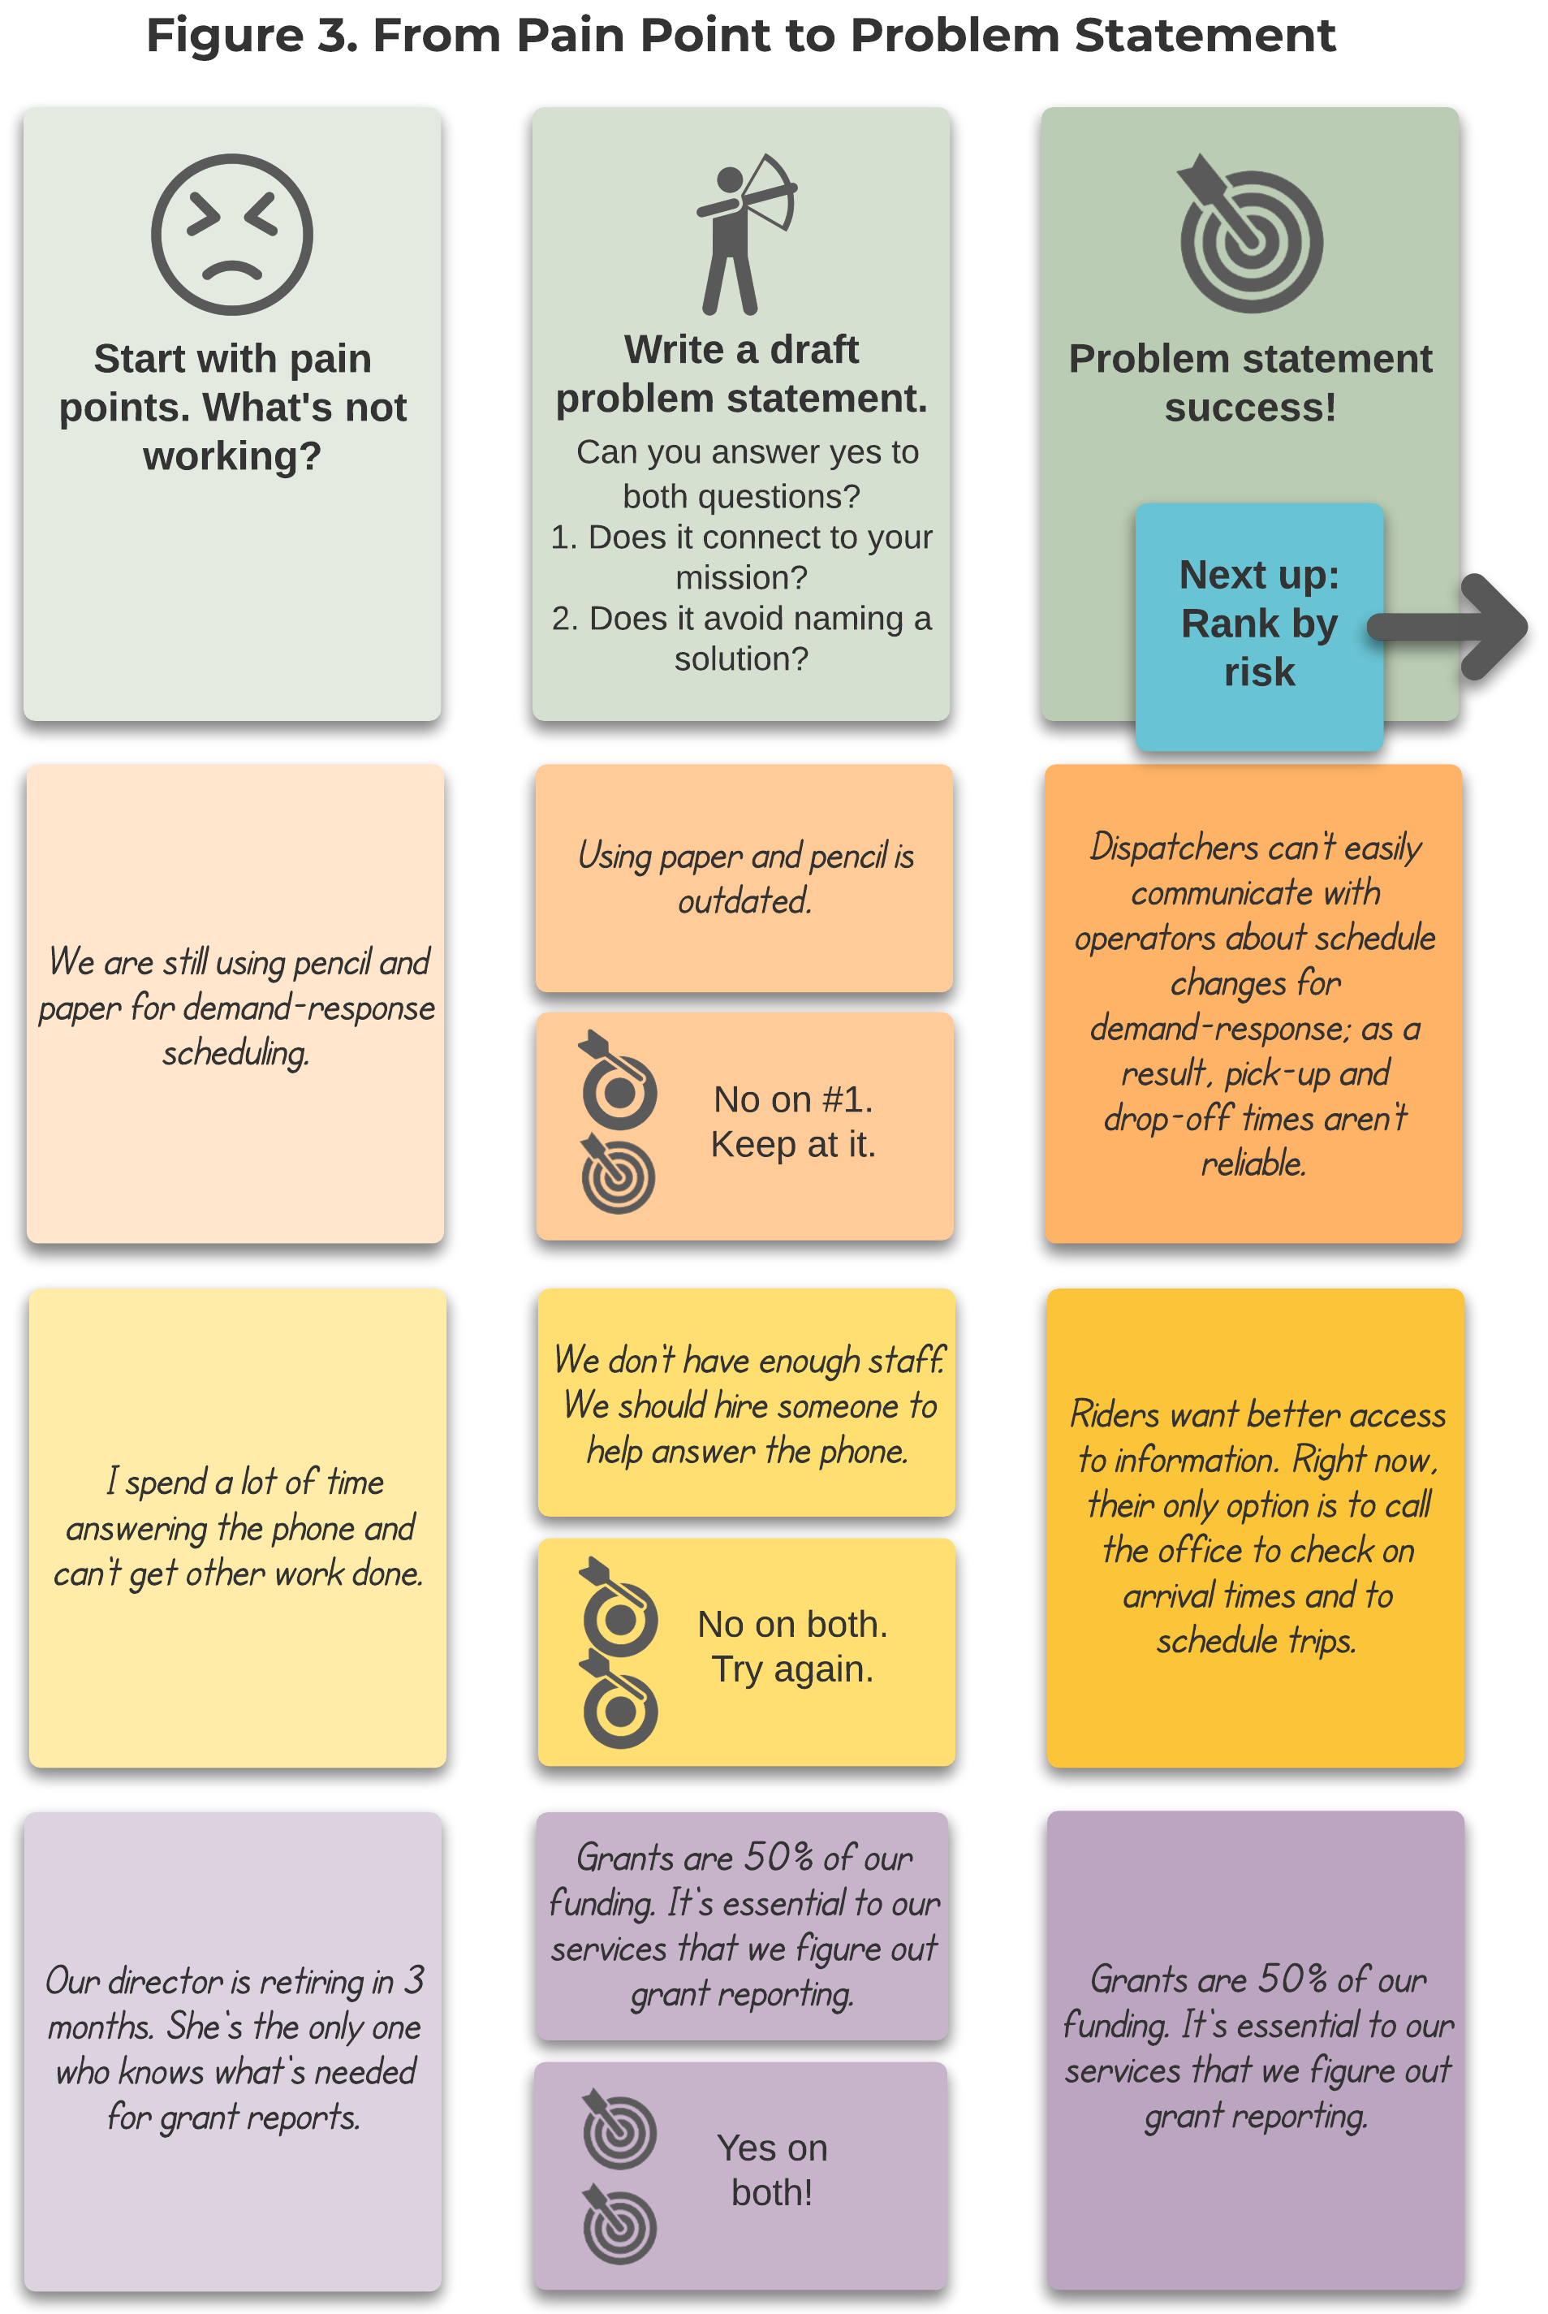

Ranking Problems by Risk
When it comes to managing risk, it’s helpful to look at two dimensions:
- What’s the level of impact of this problem/situation, especially on service reliability?
- How likely is it to occur?

Organizing Tool: Risk Management Matrix
This risk management matrix provides one way to organize a set of potential risks along these two dimensions.
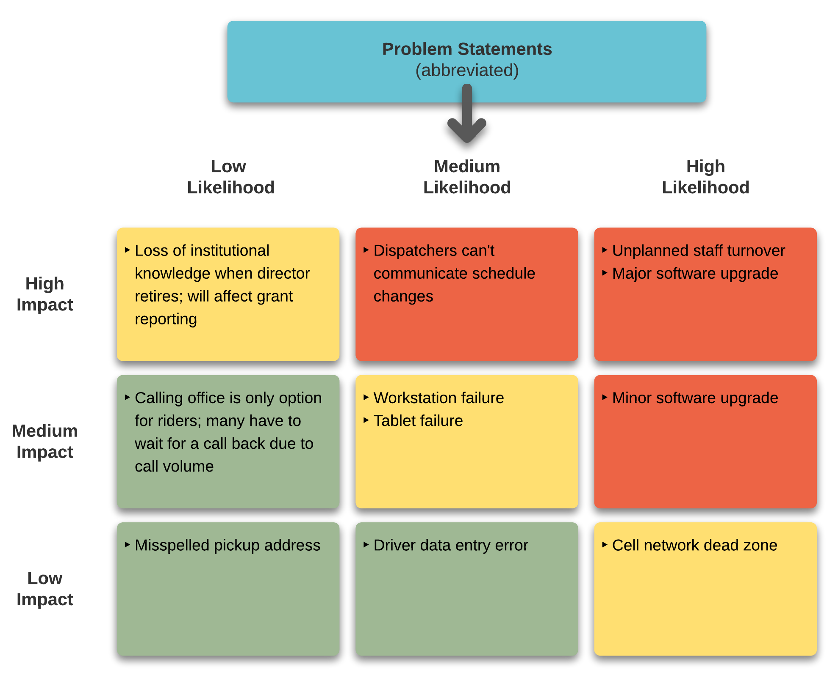Figure 4. A Sample Risk Management Matrix. (Note that problem statements from Figure 3 have been abbreviated for space considerations.)
You can place all of your problem statements within a matrix like this to help you set priorities. Your matrix will undoubtedly look different (and it should!); this example includes issues beyond technology and isn’t tied to your agency’s particular situation.
- Red: Anything that is highly likely and would have a high impact is something that you want to make sure you’re paying attention to and planning for. You’ll also want to put energy toward things that wouldn’t be terrible but would be disruptive.
- Yellow: This category is also a worthwhile area to spend time on. For instance, disaster planning needs to happen, even though disasters are infrequent. Similarly, failing computers and tablets are fairly sure to happen and would have enough of a negative effect that you want to be ready for what to do.
- Green: These issues shouldn’t take much planning to address.
This matrix is particularly useful as a reminder to look ahead at implementation and maintenance; it’s never too early to think about these phases of a technology project.
When ranking your problem statements, it’s also helpful to be as specific and as quantitative as possible when describing the costs associated with each problem. Estimates are fine, and in many cases, they’re unavoidable.

Phase 2: Develop Potential Solutions

Assemble Your Team(s)
You’ve already tapped into the expertise of your organization’s staff about what isn’t working well. Now it’s time to involve your staff in exploring ways to fix what’s broken or tweak what could be better.
We suggest forming a team or teams to investigate problems and possible solutions. A team should incorporate people representing as many roles and perspectives as possible. It’s okay if not everyone (or even if no one) feels confident about technology. Having a “beginner’s mind” can be helpful, because even a little bit of knowledge can result in blind spots. Coming to this process relatively unburdened by preconceived notions can be an advantage. We’ve written this paper envisioning agencies that don’t have dedicated IT staff, in fact.
If you are one of the valiant information technology staff serving a small transit agency (thank you!), you are probably the only in-house technologist. Your perspectives and knowledge will be essential to this process. Being involved in a team like this will help you increase your understanding of how to present a technology issue in a way that a non-technical person can better understand. And your non-technical counterparts will likely gain a greater understanding of what makes your work challenging and valuable.

Capacity Building Step #2: Establish solution space owner
For each problem statement, establish a “solution-space owner”, who will manage the exploration process and the selection and implementation of the eventual solution. Distributing these leadership roles among staff will increase the agency’s overall capacity to make good decisions. It’s crucial to make sure these people have the time to do this work, and if a leadership role is new to them, create a supportive environment for them to ask questions about their challenges.

Understand Your Systems
Your agency is aiming to end up with a successful technology portfolio, which is essentially a collection of systems that interrelate in a thoughtful and sustainable fashion.
To understand where you’re starting from, your team should map out all systems currently in place, for every aspect of your operations. You might be thinking that this should have happened earlier, prior to identifying problems. That’s certainly a reasonable thought. We put it later in the process so that your team’s first task isn’t overwhelming. It can be daunting to dig deep into the details of your operations, and we recommend beginning with pain points instead.
Consider systems in the following areas, and add others specific to your situation.
- Scheduling and dispatch
- Customer tracking
- In-vehicle technology: computer-aided dispatch and automated vehicle location (CAD/AVL); internet connectivity (routers, Wi-Fi, etc.); camera systems; stop annunciators; automatic passenger counters (APCs); headsigns; fare systems
- Reporting: for operations (for example, NTD, hours, miles, ridership) and finances
- Fleet management
- Other asset management
- Connectivity: telephony, internet at facilities, and mobile network or radio in the field
For each system, document the available budget, staffing, and existing infrastructure. It’s also a good time to assess each system’s reliability, usefulness, and time frame for mandatory replacement.
Take the time to examine the workflows for each system. These steps can be so routine that it may be hard to articulate them. Writing down each step in your current processes will help you later on, when you are evaluating the impact of a new technology on your existing workflows.
As you build this map, you’ll undoubtedly identify systems that you’d like to have, even if it’s in a vague way (“better scheduling” for instance). You’ll also want to think about what kind of budget, staffing, and infrastructure would be needed to support these new systems. In thinking about the budget, keep in mind that grants are great for purchasing and implementing, but your budget needs to account for the full life of any purchase. Be clear-eyed about what resources are available for long-term maintenance and staff training. At this point, you may not know enough about new technologies to make accurate forecasts of necessary resources; that’s fine. Any information gaps can become part of your research priorities.

Build Knowledge by Casting an Even Wider Net
A solution team’s main task is to gather information that will build the agency’s collective expertise. Whether team members are working in unison or individually to build knowledge, we recommend going outside your organization to learn more.
No matter who you’re talking to, take every opportunity to ask about costs and what others are getting or producing for that cost. You’ll be able to form better cost estimates as a result.
Above all, expect and plan for this stage to take time. You’re investing in this process so that you ultimately have solutions that meet your specific needs. Below, we’ve shared four potential sources of information and support.

Reach Out to Vendors, Peers, and Aggregators
You’re not alone! Even though your agency might feel unique in terms of the mix of services, funding sources, or other constraints, you have access to a large number of people who run transit agencies who have felt the same way about technology, whether that’s skeptical, reluctant, overly optimistic, overwhelmed, or some combination that we haven’t thought of. Even if they haven’t solved the same problem that you have, in the same way that you will ultimately implement locally, you have peers who have moved from having a problem to incorporating some kind of technology to solve it.
Getting advice and guidance from people who’ve been part of technology implementations can help you build your expertise in making technology decisions. You can do this by reaching out to peers that you know have done something similar to what you are planning, contacting knowledge aggregators like the National Center for Applied Transit Technology, National Rural Transit Assistance Program, Federal Transit Administration, National Center for Mobility Management, and your state DOT and/or issuing a Request For Information (RFI) prior to releasing a more formal Request For Proposals.
Issuing an RFI is usually not required in a procurement process. You should choose to develop an RFI only if you see a clear need for one and if you have the capacity to implement the process. You could also take an even less formal route, by reaching out to vendors you already know about or asking for recommendations from your network.
Whether you call it an RFI or not, this optional action has several advantages when it comes to building your expertise with technology decision-making.
- Informally gathering information: Although an RFI involves a structured request, it is substantially less formal than an RFP process. An RFI can spark conversations that are not possible once you’ve issued an RFP.
- Developing relationships: You will likely get RFP responses from a wider network with an RFI than without one.
- Surveying the market: By finding out more about what’s out there (from vendors and from the agencies that use these products), you are becoming a more informed consumer.
We admit to having a preference for RFIs over Requests for Qualifications (RFQs), simply because an RFI is open to input from other agencies and groups like N-CATT, too. It’s helpful to hear from people who use technology as well as those who sell it. Building your expertise in terms of what’s on the market and what other agencies have already done may help you refine your understanding of your problem.

Learn from Other Industries
The wide net you’re casting can also stretch outside the world of transit agencies. Other industries have problems that are similar, if not the same, as transit organizations. Any industry that manages a fleet of vehicles has probably thought about in-vehicle cameras and asset management. Logistics companies, for instance, are close cousins of transit.

Going to a Conference? Map Out Your Strategy
Conferences can present a dizzying array of learning opportunities. When you’re trying to gather knowledge related to a specific problem area for your agency, it’s a good idea to have a conference game plan. Before you go, make lists of whom you want to talk to, whether that’s a hallway conversation with an agency peer or a chat at a vendor’s booth.
Have a clear research agenda. Be ready to ask vendors the questions that matter to you about their products, maintenance/support services, and overall costs. Vendors are most likely to send members of the sales team to a conference, but sometimes their engineers also attend. Regardless of who you’re talking to, your goal should be to get a good sense of their product’s capabilities, using strategic questions such as:
- What do your most successful product implementations have in common?
- Who do you think your ideal client is?
- Where does most of your business come from? (This could be in terms of geography, agency size, type of service—however they choose to answer.)
- When have you seen clients get stalled in implementing your product?
- Where do clients stumble as they use your product?
- What do you think a client should have in place before they adopt your product?
You will likely hear a lot about the strengths of their product, so much so that you may wonder if there are any flaws at all. However, as you listen to their answers, look for what they didn’t say. For instance, if they primarily serve fixed-route service providers and your primary need is for demand-response scheduling, that’s an area of potential mismatch. If you’re able to make these connections in the moment, fantastic; if you need to take some time after the fact to reflect, that gives you a starting point for a follow-up email or phone call with the vendor.

Do You Need a Consultant?
Knowing whether to bring in a consultant can be tough. How can you know if you’ll realize any return on the investment, both in terms of the contracting cost and your time? If you’re starting to think about seeking consulting support, consider reaching out to your peers or staff at technical assistance centers like N-CATT, National RTAP, NCMM, or your state DOT. These resources can provide a reality check about whether you need an ongoing outsider perspective, and they may have suggestions about where to turn.
There are at least three situations where we’ve seen consulting services present clear advantages:
- Significant investment is required and your team is in unfamiliar or rapidly changing territory. When you are considering spending a good deal of money (you’ll need to define what constitutes “a good deal of money” for yourself) and you aren’t comfortable with the subject matter, a consultant with relevant expertise can help you learn what you need to know, so that you can spend your time and money wisely.
- Problem definition. When you and your team are unable to define a clear problem statement, a consultant can facilitate conversations to uncover needs from all stakeholders, build a shared understanding of a project’s purpose, and share experience about how other agencies have solved similar problems.
- Implementation/project management. You may have a solid statement of what you want to accomplish but no staff capacity to draft the RFP or oversee the implementation. Or maybe the implementation steps require technical expertise that you don’t have in house. In these scenarios, a consultant can work from the decisions you’ve already made about the project requirements and timeline.
Though procuring consulting services can be its own painful process, the combination of industry expertise and fresh perspectives can make the difference when the path forward is unclear.

Set Priorities
As your team wraps up its knowledge-gathering activities, it’s time to review what you’ve all learned. Revisit your risk management matrix to see if your assessments have changed. Fill in anything that wasn’t previously accounted for, whether that’s a more informed cost estimate or a new risk you hadn’t thought about.
As you match possible solutions to the risks, an outline of your priorities should begin to emerge. It may be tempting to address all the most important/highest risk areas right away, but it’s very important at this point to think about your agency’s capacity to implement. Most of the time, you’ll do well to work in phases, starting with the most important or foundational elements first. Consider that unplanned staff turnover or other risks may happen, and think through the steps you’d take to mitigate these risks.

Comparing Your Options
At the same time that managing transit is inherently complex, small urban and rural transit occupies a small niche in the overall mobility landscape. Although we dearly want plug-and-play solutions, oftentimes, those are not currently available for our industry. As a result, we have to be exceptionally rigorous when we examine different options available to us.

Know What’s Most Important
Costs and benefits don’t always translate directly to dollars or any other quantifiable numbers. The impact of rider-facing amenities is often stated in qualitative terms, which brings a good deal of subjectivity into the picture. Your cost-benefit analysis is going to come down to saying, "This is how important x is relative to all our other concerns." An agency strategic plan is the first place to turn for that kind of prioritization; if none is available to you, seek to align your ranking of different options with priorities that your agency has already set as much as possible.
You need to be ready to rank different options—and to be ruthless every time. This diligence will keep you focused on what’s truly most important to meeting your ultimate goal of improving the rider experience at a sustainable pace. Be sure to keep the costs and benefits of the status quo in the running as a real option so that change for change’s sake doesn’t get an implied boost in the analysis.
Take care to consider both a technology’s public visibility and its value to the service your agency already provides, and be clear about what you are trying to accomplish. Are you intent on converting non-transit riders? Are you aiming to meet the needs of an agency’s core rider population? It’s important to be explicit about your goal.
It can be an uphill struggle to prioritize investments that substantively support the rider experience when there are flashier projects that garner more attention from the non-riding public. This is especially true with technology investments. In recent years, venture capital-funded ride-hailing businesses have exerted a great deal of influence on the general public and policymakers alike, resulting in a significant overweighting of the value of mobile device apps and the types of services that rely on them.
To help them better understand the nuances of rider-centered technology investments, it may be useful to take the time to share a “Transit 101” overview for your board and other key decision-makers. This can include topics outside of technology decision making. You may want to cover issues like:
- Why service reliability matters more than almost anything else—and what can be done to increase it
- Why using smaller buses won’t save money, and where the real costs of transit are
- Why some improvements enhance agency scalability and others do not

Remember: Technology Wasn’t Necessarily Built with You in Mind
You’ve already spent a good deal of time articulating the problem you want to solve. It’s complex, but you are convinced that the tech companies must have already accounted for everything. It’s all built in already, so all that’s necessary is finding the right vendor who will Solve All the Problems.
Well, maybe. It’s true that there is a lot of software out there that seeks to automate workflows, for instance. But every organization is different, and so you have to dig into the assumptions that the software makes about how your organization works. Earlier in the process, your team mapped out your existing workflows, and now it’s time to compare them to the workflows that were assumed during the software design process.
To get a sense of what this workflow comparison process would look like, consider what it was like for you to switch from a flip phone to a smartphone or to help someone else make that transition. You had a piece of technology that you knew how to use, even though it had its limits. Then you replaced it with one that could do everything that your flip phone could do and so much more. You needed to relearn the steps for making a call, sending a text message, saving someone’s contact information, and taking a photo, among other things. You probably moved from pushing manual buttons to a touch screen. You didn’t have the option to replicate the actions that you were used to taking to accomplish a task. You had to learn the new workflows that were built into your new phone.
The same kind of transition will be necessary for any new transit technology you adopt, but at an organizational scale. If you opt to go with an existing product, be aware that you will need to adapt to the workflows that come along with it. When you commit to a vendor, prepare for the organizational change that entails. By engaging a broad cross section of your staff in the overall process, you’ve set yourself up for a greater chance of success if new workflows are necessary.
It is likely that a vendor can make adjustments for your type of operations, but that adds to the cost and complexity of your project. Like everything else, customization has its costs and benefits to weigh carefully, and you’ll need to understand the amount of necessary customization in order to make that analysis.

What Can You Commit to Maintaining?
As you look at costs and benefits, don’t forget to assess the complexity of what you’re considering when it comes to maintenance. Of course, it’s important to think about your implementation plan and all the potential disruption of a technology transition will cause. But the main limit around technology is less about what we can implement. Rather, it's what we can maintain. Talk to other agencies that use the product or products you are considering about their experiences. How much time does the specific technology you’re interested in require as far as maintenance goes? What steps are involved? Take the time to work backward from the resources that will be available to you once everything's in place, and evaluate your ability to maintain each option that you’re considering over time. If you can already foresee that one of your options will take too much time or money to maintain, cross it off your list.
A common misconception is that a new system will need less time for maintenance—or even that it will be maintenance free. As soon as possible, confront this line of thought with a reality check. New technology is more likely to change how time is spent rather than save time. You may gain efficiency in one area of operations, but that will likely be at least partially offset by additional maintenance requirements. It’s up to you to assess whether that trade-off is worthwhile in your situation.

Term to Know: Software as a Service
As you consider your options, you may encounter the acronym SaaS (pronounced “sass”), which stands for software as a service. SaaS products represent a different method of getting access to software. In the past, software would be “locally hosted”—installed directly to your workstation and/or your on-premises server. You’d pay for the software licenses as capital expenses. The software “lived” on your computers, and whenever the software company developed a new version, you were responsible for manually loading the upgrades, probably from a disk, CD, or other physical storage device.
With SaaS, the software lives on servers at a remote data center, not on any of your hardware. It’s “web hosted”, rather than locally installed, and you access it via the internet. The software company is responsible for making sure the software on the remote server is up to date. Rather than paying a one-time purchase price, you pay a subscription fee to have access to the latest version of the software. You’ve probably seen notifications on your computer along the lines of “The system will be down from 1 a.m. to 3 a.m. on date X for a version upgrade”. The next time your computer restarts, it will have all the latest features and bug fixes for that program. No CDs required!
Chances are good that any software you purchase today will be provided under a service-based model. If you currently have locally hosted software, it’s likely that the software vendor will at some point stop providing support for it, if they haven’t already. When you make the transition to SaaS, you’ll need to consider some operational issues.
One risk with SaaS is that if your internet connection is down, that means you can’t access your software—which can paralyze scheduling and dispatch, among other critical operations. Since implementing SaaS usually results in some cost savings over locally installed software, a good use of those dollars is to build redundancy into your network, either through a system that automatically switches to a second wired connection (available in many urban areas) or to cellular service (often the only other option in rural areas).
Another risk with SaaS comes from the SaaS provider itself; their systems can go down, too. Any SaaS provider should be able to provide information about their “uptime” history and how they will communicate with you about service disruptions. These issues should also be clearly addressed in their service-level agreement (SLA), in terms of the guarantees they provide regarding uptime and the compensation given when those guarantees aren’t met.

How Well Do Existing Technologies Serve Your Needs?
After gathering information about potential solutions to your high-priority concerns, it’s time to step back and review them. This is where two tools for systems thinking come into play.

Organizing Tool: Design Thinking
Design thinking allows you to be flexible and iterative when considering multiple options and how they might fit together. It’s also a good method for testing out whether you can minimize the use of new technology; maybe you have a pencil-and-paper system for scheduling that’s actually working better than any electronic system would, given your situation. As a fairly open-ended process, design thinking can be difficult to use when a project involves a set budget or timeline, however.
There are cases when design thinking alone isn’t going to be enough. You’ll need additional tools if:
- You reach the conclusion that the current marketplace simply doesn’t address your problems;
- You see that your needs can only be met by chaining together a series of independently produced technologies; or
- You are coordinating across several agencies to unite different technologies in a way that should be seamless for riders.

Organizing Tool: Systems Engineering
These situations benefit from systems engineering. Whether and how much engineering to do is a key decision-point. Your team should consider the following questions carefully:
- Are there any off-the-shelf solutions?
- How much new engineering is truly needed, and why? (e.g., there’s no solution in the marketplace, required integration with legacy systems, etc.)
- What are the ways to minimize new engineering and instead rely on the prior engineering work of vendors?
- What are the mature or developing standards you can lean on?
- If the goal is to forge new ground or address an as-yet unmet technology need, who can be your strategic partners? Who are the potential peers, coordinating bodies, funders, or other players who can team with you?
Systems engineering isn’t for everyone. It requires considerable agency capacity, and it’s only worth doing if your project demands it and if you can devote time and money to do so.
If your task is complex enough to require systems engineering, it’s worth considering whether you want to build a solution that neighboring agencies could use to address common issues. Pooling resources can help offset some stresses, and, perhaps, reduce expenses, but it requires considerable time for coordinating efforts. Asking yourself whether teaming up with your peers is a good question for your analysis; just remember that you need to take the same hard-eyed approach to assessing the associated costs and benefits.
Design thinking and systems engineering can complement each other. For example, engineered elements can be procured one by one according to an iterative master plan. The plan can then be refined after each successive piece is put into place.

Use Standards and Advocate for More Standards
Having data in standard formats is incredibly powerful; it allows us to share information across agencies. One of the most important applications of data standards is trip planners that pull in information from multiple transit providers. Thanks to General Transit Feed Specifications (the oldest and most mature standard in transit) and its extension, GTFS-flex (which deals with demand-response transit), it’s possible for independent agencies to present a seamless interface to riders for trip planning.
What does this mean for your decision-making process? You should always ask vendors about their products’ standards compliance. Emphasizing standards and interoperability between engineered components allows for gradually adjusting how pieces connect or swapping out of components. It’s not quite a plug-and-play solution, but standards will help you get closer to that.
In the case of a mature and public-facing standard such as the GTFS, it’s important to require that a product support the standard in a high-quality way. For example, it’s essential to confirm that a product’s GTFS output will represent your agency’s services accurately when they appear in Google Maps or other tools.
GTFS and GTFS-flex are powerful, but they don’t cover everything that we deal with in transit. Many other standards are in development. You don’t have to become an expert in all these standards (although if that’s appealing to you, go for it!). The most important thing you can do is bring an awareness of standards to your decision-making process. As you talk with vendors, you can help nudge them to be thinking ahead about these proto-standards and how they should be incorporating them in future versions of their products.

Leaders: Think in Trade-Offs and Be Ready to Make Hard Decisions
If you trace back the path of many successful technology decisions, you’ll often find that an agency leader had to make a hard decision, say, forcing two agencies to merge or scrapping an entire fare scheme. These decisions can be necessary in order to make a technology solution (and the ultimate goal of improvements for riders) viable. More often than not, these leaders have had to think about trade-offs. Sometimes that analysis involves comparing significant initial effort versus a long-term payoff.
But making decisions at this scale takes leadership. You have to create a vision and then lead your team and external stakeholders through that change. Above all, you can't just think, "Oh, we just need to buy this technology, and that’s it. Our problems will be solved. The technology will take care of everything." Whatever technology we pursue for our agencies is part of a much more complex system, and we need strong leadership to help the people who are also part of that system embrace the changes new technology can require.

Phase 3: Procuring
Procurements can be painful. Here are some practices to help make it easier.

Capacity Building Step #3: Put the solution-space owner and other affected staff in decision-making roles
  - Assemble a review committee that includes the solution-space owner and other affected staff, to continue the commitment to agency capacity building.
  - Explore areas for contracting where the vendor’s revenue model aligns with agency outcomes. For example, can you provide bonuses or other incentives if clearly defined outcomes are met, such as cost savings, improved on-time performance, etc.?
- Look into whether your solution can be procured under the cost threshold for a formal procurement. Due to the pricing structure of SaaS subscriptions, you may be able to stay below the formal procurement bar for new software.
- For elements you’ve engineered, lay out all your work: requirements, designs, phasing.
- For problems for which you’re seeking an already engineered solution, don’t over-prescribe. Instead, focus on communicating as simply as possible your conditions, the problems you’re trying to solve, and the outcomes you expect.

Phase 4: Implementation and Maintenance
As with procurement, successful implementation of a technology project is a topic worthy of further consideration. You’ll need to develop a plan for getting the solution in place and for maintaining it for the long haul. The specifics will vary widely depending on what you’re implementing. Some considerations apply universally, however.
- Capacity Building Step #4: Leave the solution-space owner in a leadership role during implementation
  - For the sake of continuity, the solution-space owner should retain a leadership role during implementation and maintenance.
- If you’ve chosen to go with a solution engineered by a vendor, then commit and see that process through.
- Organizing Tool: RACI Matrix
  - Sustain your capacity-building efforts by clarifying roles and responsibilities. Outline roles for implementation and ongoing maintenance across the organization according to whether someone is responsible, accountable, consulted, or informed (RACI). These roles can be summed up in a RACI matrix.
- To the extent the solution involves disruption of established roles, the engagement of top-level leadership is essential.
Your work doesn’t end with implementation, however. In the same way that you pay careful attention to ongoing maintenance needs of your fleet vehicles, you also have to develop a technology maintenance mindset. The workings of technology may feel invisible, but they do still need to be tended. You’ve committed a lot of time and money to getting these systems in place, and you’ll want to keep them in good working order. Again, the details will vary depending on what technologies you’re using. As needed, ask for help in developing a maintenance plan from peers at other agencies, your IT department, your vendors, or outside consultants, as appropriate.

Conclusion
Working with technology need not be the exclusive domain of large organizations with dedicated IT departments. The approach proposed here won’t make the task as easy as screwing in a light bulb, but through a systems thinking process and organizational capacity building, it can bring technology projects within the reach of even the smallest organization. The steps outlined above are intended to uncover root problems and provide steps that increase the likelihood of arriving successful technology implementations, while also building the skills in the organization that make managing technology sustainable over time. The overarching goal is to have a team that can be in the driver’s seat technology with regard to technology, rather than one that hopes that technology will lead the way on its own.
This framework for decision-making offers a way to make sense of the not-quite-perfect world of transit technology, and we have no illusions that the framework itself is perfect, either. In addition to helping your agency find technology solutions that help you achieve more for your clients, technology decision-making can be used as an opportunity to empower staff and increase their capabilities. That also means it should empower you to deviate from this framework when it isn’t serving you. It matters less what organizational tool you select than that you pick one and use it to get people on the same page. You and your team are the experts on your community, your agency, and your needs, and so whenever your reality presents a situation that isn’t accounted for here, lean into what you know.

For more information on the ridership-coverage tradeoff, see Chapter 10 of Human Transit by Jarrett Walker. A summary by Christopher Yuen can be found at https://humantransit.org/2018/02/basics-the-ridership-coverage-tradeoff.html.
Daniel H. Kim, “Introduction to Systems Thinking”, available at: https://thesystemsthinker.com/wp-content/uploads/2016/03/Introduction-to-Systems-Thinking-IMS013Epk.pdf
One resource we suggest: “Habits of a Systems Thinker”, from the Waters Foundation for Systems Thinking, https://waterscenterst.org/systems-thinking-tools-and-strategies/habits-of-a-systems-thinker/
https://www.interaction-design.org/literature/topics/design-thinking
Source: https://ops.fhwa.dot.gov/publications/seitsguide/section3.htm#s3.3
See Chapter 2 of Human Transit by Jarrett Walker. A summary of the core expectations can be found at https://humantransit.org/2011/12/outtake-on-endearing-but-useless-transit.html.
https://en.wikipedia.org/wiki/Responsibility_assignment_matrix

