Building Successful Partnerships between Rural Transit Systems Deploying Zero-Emission Vehicles and their Electric Utilities

Prepared for:

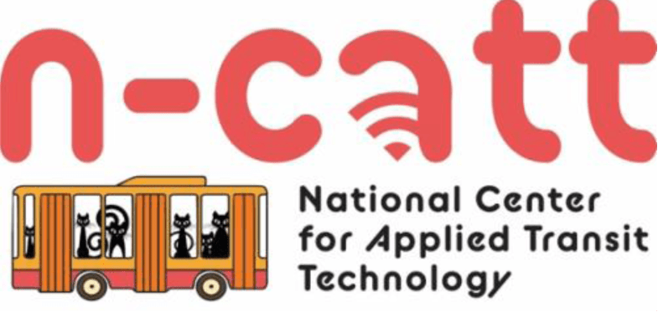

Prepared by:

Maggie Maddrey

Amy Posner

Center for Transportation and the Environment

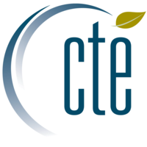

Acknowledgements

This work was funded by the National Center for Applied Transit Technology (N-CATT).

The Center for Transportation and the Environment thanks the external reviewers that have made substantial contributions to this white paper:

Erik Bigelow, Senior Engineering Consultant, Center for Transportation and the Environment

Chris Bilby, Research and Programs Engineer, Holy Cross Energy

Mary Ann Hayes, Multimodal Planning Division Manager, Maine Department of Transportation

Lisa Jerram, Director, Bus Programs and Emerging Vehicle Technologies, American Public Transportation Association

Cara Marcus, MSLIS, AHIP, Resource Center Manager, National Rural Transit Assistance Program

Chris Michalowski, Power Use Advisor, Mountain Parks Electric

Brian Sloboda, Director of Consumer Solutions, National Rural Electric Cooperative Association

Alison Smyth, Lead Engineering Consultant, Electric Utility Specialist, Center for Transportation and the Environment

Jennifer Wallace-Brodeur, Director, Transportation Efficiency, VEIC

Jason White, Transit Planner, Roaring Fork Transportation Authority

****Table of Contents****

Introduction 4

1 Zero-Emission Vehicles Overview 5

1.1 Zero-Emission Transit Buses 6

1.2 Zero-Emission Cutaways 7

1.3 Zero-Emission Passenger Vans 7

1.4 Not Just Transit 8

2 Working with your Electric Utility During Fleet Electrification 9

2.1 Understanding your Type of Electric Utility 10

2.1.1 Investor-Owned Utilities 12

2.1.2 Public Power Utilities 12

2.1.3 Electric Cooperatives 13

2.2 Understanding your Utility Bill 14

2.2.1 Typical Bill Components 14

3 Framework for Building Partnerships Between Transit Agencies and Electric Utilities 16

3.1 Set Fleet Electrification Goals 16

3.2 Technology Assessment 18

3.3 Exploratory Meeting with your Electric Utility and Other Stakeholders 18

3.4 Identify Funding Sources 20

3.5 Rate Optimization 21

3.6 Realize Fleet Electrification Goals 23

4 Additional Resources 23

References 24

Introduction

Transit agencies around the world are deploying zero-emission vehicles (ZEVs) into their fleets. ZEVs are quieter, cleaner, and more efficient than conventionally-fueled vehicles. ZEVs produce no harmful tailpipe emissions and do not rely on fossil fuels to operate, which helps mitigate the impacts of climate change. By reducing air pollutants and greenhouse gas emissions, ZEVs result in cleaner air and healthier communities than those using vehicles that run on fossil fuels. Transportation is the largest contributor to greenhouse gas emissions in the U.S., accounting for almost 30% of total emissions. More than 25% of transportation-related emissions come from the medium- and heavy-duty vehicle markets (EPA, 2017). While ZEVs tend to have higher capital costs than conventionally-fueled vehicles, ZEVs may also have lower operating and maintenance costs, which may reduce lifetime costs of these vehicles.

**Serving Environmental Justice Communities**

A study by the Union of Concerned Scientists found that on average, African Americans, Asian Americans, and Latinos breathe in about 66 percent more particulate matter from cars, trucks, and buses than white residents in 12 Northeastern/Mid-Atlantic states (Reichmuth, 2019). Deploying ZEVs on blocks that serve environmental justice communities provides direct health benefits to the people living there. Some transit agencies prioritize routes in environmental justice or disadvantaged communities when making ZEV deployment plans.

For transit agencies considering fleet electrification, a strong relationship with the local electric utility is critical, as adding ZEVs to your fleet could lead to you becoming one of your utility’s largest customers. Your utility can help your transit agency understand how different ZEV charging or fueling strategies can minimize electricity costs and what electrical infrastructure upgrades are needed to support ZEV deployments. Effective planning early in the process will help guide your investment strategy for implementing electrical upgrades and help you minimize electricity costs.

In 2015, 1,334 rural transit agencies provided 132 million rides, over 490 million miles of service, and 28 million vehicle hours of service (Mattson, 2017).

This white paper includes the following sections:

* ***Section 1. Zero-Emission Vehicles Overview*** includes details on available zero-emission vehicles that rural transit agencies are likely to have in their fleets, including heavy-duty transit buses, cutaways, and passenger vans.
* ***Section 2. Working with your Electric Utility During Fleet Electrification*** includes an overview of the features and constraints of each utility type (i.e., investor-owned utilities (IOU), public power utilities, and electric cooperatives (co-ops)) and an overview of common components of your transit agency’s electricity bill.
* ***Section 3. Framework for Building Partnerships Between Transit Agencies and Electric Utilities*** providesa framework for your transit agency to use when coordinating with your electric utility on fleet electrification.
* ***Section 4. Additional Resources*** lists resources that provide additional information on the topics described in this white paper.

This white paper focuses on battery electric vehicle technology and charging infrastructure. For transit agencies considering fuel cell vehicle technology, see N-CATT’s white paper, [*Hydrogen as a Transportation Fuel in Rural Communities*](https://n-catt.org/category/whitepapers/)*.* Note that hydrogen fueling infrastructure will likely increase your transit agency’s energy consumption; therefore, coordination with your electric utility will still be critical, especially if you are planning on producing hydrogen on site at your facility.

# Zero-Emission Vehicles Overview

**A Note on COVID-19**

When this white paper was written, all transit agencies in the U.S. are struggling with the impacts of COVID-19. Transit agencies will be operating under a “new normal” for some time due to ridership changes and financial difficulties due to the pandemic. This resource was written to be evergreen, but all decisions to deploy ZEVs must be evaluated within your transit agency’s priorities and available resources. [Visit N-CATT’s website for valuable resources for transit agencies on responding to COVID-19.](https://ctaa.org/covid-19-resources/)

Zero-emission vehicle technology has advanced significantly in recent years, especially in regards to zero-emission, heavy-duty (30’ to 60’) transit buses. For rural transit agencies, heavy-duty buses are not as prevalent in operations as they are for urban agencies, but they are still used. Cutaways are the main vehicle type used in rural agencies, however minivans and vans also make up a large portion of vehicles used by rural transit agencies. Zero-emission cutaways and passenger vans have entered the ZEV market more recently than heavy-duty transit buses and fully commercialized options are limited. General information on zero-emission transit buses, cutaways, and passenger vans, the most commonly used vehicles by rural transit agencies, are listed in the sections below (Mattson, 2017). Plug-in hybrid models may also be available for certain vehicle types but are not described further in this white paper. Deployment of plug-in hybrid vehicles would still require close coordination with your electric utility.

## Zero-Emission Transit Buses

Both battery electric buses (BEB) and fuel cell electric buses (FCEBs) are on the market today. There are 30’, 35’, 40’, 45’, and 60’ BEBs available and 40’ and 60’ FCEB options. Original equipment manufacturers (OEMs) that offer Buy America-compliant BEBs include BYD[1], Complete Coach Works (CCW), Gillig, GreenPower, Proterra, New Flyer, and Novabus. OEMs that offer Buy America-compliant FCEBs include New Flyer and El Dorado National-California (ENC). **Table 1** shows typical specifications for long-range BEBs, fast-charge BEBs, and FCEBs.

Note that some transit bus manufacturers can install a fuel-fired heater to extend battery range in winter months. Emissions from the heater need to be taken into consideration when quantifying emissions reductions.

*Table 1. Typical Specifications of Zero-emission Heavy-Duty Buses on the Market*

|  | Battery Capacity | Fuel Cell Power | Reliable Range in Transit Service | Estimated Capital Cost for Base Vehicle | Typical Fueling Approach |
| --- | --- | --- | --- | --- | --- |
| Long-Range BEBs | 250 – 660 kWh | N/A | < 150 miles on a single charge | $740k | DC fast charging (50-150 kW)  3 to 9 hours to fully recharge |
| Fast-Charge BEBs | 50-250 kWh | N/A | Indefinite range possible with periodic on-route charging | $750k-1M | Overhead conductive chargers (175-600 kW)  Wireless inductive chargers (50-250 kW)  Typically charged for 15-20 minutes per hour |
| FCEBs | 50-150 kWh | 85-120 kW | 200-320 miles | $1M | Hydrogen fueling via delivery or on-site production  Similar fueling time to a CNG bus |

## Zero-Emission Cutaways

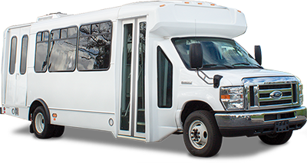

Figure 1. A battery electric cutaway from Motiv Power Systems (Shuttle Bus, 2020)

Zero-emission cutaways are newer to the market compared to zero-emission transit buses; therefore, fewer options are available. In 2020, Lightning Systems, Motiv Power Systems, and Phoenix Motors are OEMs offering battery electric cutaways, all three of which have not been Altoona tested by mid-2020. Zeus Electric Chassis and ARBOC Specialty Vehicles are in the process of developing electric cutaways, while U.S. Hybrid has developed a demonstration fuel cell electric minibus. **Table 2** shows the specifications for electric cutaway options from Phoenix, Lightning, and Motiv that are on the market as of mid-2020.

Table 2. Specifications for Electric Cutaways

|  | OEM-Advertised Max Battery Capacity | OEM-Advertised Range | Typical Fueling Approach |
| --- | --- | --- | --- |
| Lightning’s E-450 Cutaway | 129 kWh | 80 - 120 miles | Level II depot charging or DC fast charging  3 to 7 hours to fully recharge* |
| Motiv’s Champion Shuttle Bus | 106 kWh | 85 miles | Level II depot charging or DC fast charging  2 to 5 hours to fully recharge* |
| Phoenix Motors’ Zeus 400 Shuttle Bus | 150 kWh | 160 miles | Level II depot charging or DC fast charging  3 to 8 hours to fully recharge* |
| * Assumes a 20 kW and 50 kW charger | | | |

## Zero-Emission Passenger Vans

Like zero-emission cutaways, zero-emission passenger vans are also newer to the market. In 2020, GreenPower Motor Company and Lightning Systems are offering battery electric cutaways. GreenPower Motor Company’s EV Star completed Altoona testing, while Lightning’s Ford Transit LEV60/120 has not been Altoona tested by mid-2020. **Table 3** shows the specifications for electric passenger van options from GreenPower and Lightning that are on the market as of mid-2020.

Table 3. Specifications for Electric Passenger Vans

|  | OEM-Advertised Max Battery Capacity | OEM-Advertised Range | Typical Fueling Approach |
| --- | --- | --- | --- |
| GreenPower’s EV Star | 118 kWh | 150 miles | Level II depot charging or DC fast charging  3 to 7 hours to fully recharge* |
| Lightning’s Ford Transit LEV60/120 | 43 -86 kWh | 60 - 120 miles | Level II depot charging or DC fast charging  1 to 4 hours to fully recharge* |
| * Assumes a 20 kW and 50 kW charger | | | |

## Not Just Transit

In addition to transit vehicles, other fleets in rural areas are considering electrification, including school districts; local, county, and state governments; logistics; and trucking companies. Lessons learned from one fleet type in your area will most likely translate to another fleet type. There may also be opportunities for shared charging or fueling infrastructure between zero-emission fleets in your area. Engage with other fleet operators in your area when planning for or deploying ZEVs.

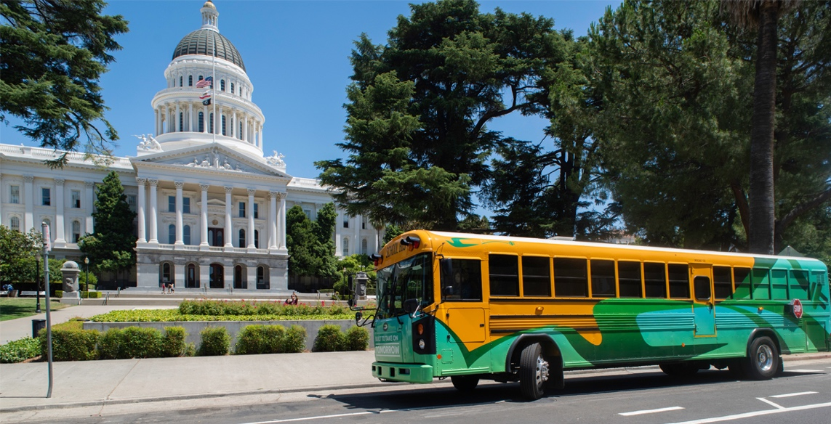

Figure 2. BlueBird electric school bus in California (Adomani, 2018)

Mountain Parks Electric (MPE), a rural co-op located in Granby, Colorado, worked with the West Grand School District (WGSD) to apply for and secure a Colorado state grant to procure a battery electric school bus (Mountain Parks Electric, 2020). The grant did not cover the entire cost of the electric school bus; therefore, MPE and Tri-State Generation and Transmission contributed additional funds, which allowed WGSD to procure a Blue Bird electric school bus (**Figure 2**) at no cost to them. The bus is expected to be delivered in October 2020.

# Working with your Electric Utility During Fleet Electrification

When electrifying your transit agency’s fleet, establishing and maintaining a relationship with your local electric utility is critical for a successful deployment. Adding ZEVs to your fleet could make your agency one of your utility’s largest customers, while some utilities might not even be aware that they have transit customers in their service area. Many electric utilities in the U.S. are interested in exploring options for fleet electrification and will be supportive partners throughout vehicle deployments. Benefits of partnering with your electric utility include:

* **Understanding each other’s constraints** - Both transit agencies and electric utilities have constraints and considerations that may not always align. For example, your utility may prefer that you limit your charging to defined off-peak times, such as overnight. While this might be possible, you may need to charge during peak times, such as a mid-day charge, to meet your service requirements.
* **Lowering operational costs** – Your utility can help you understand how your electricity rate schedule will change as you incorporate ZEVs into your fleet and provide guidance on charging or fueling strategies that will minimize costs. Rates or pilot programs may be available that support electrification.
* **Making smart investments** – Electrical upgrades will likely be required to support ZEV charging or fueling. Your utility can help you plan for when infrastructure upgrades should be made based on your short- and long-term fleet goals. Your electric utility may be following the latest trends in electric vehicles and can provide valuable information and insights to support your decision-making processes regarding deployment of electric vehicles. **Figure 4** shows the typical electrical infrastructure assets that belong to a utility (from the transformer to the meter) and those that belong to the customer (from the meter to the EV charger).

**Time-of-Use Rates:**

**Peak vs. Off-Peak Periods**

Some utilities implement time-of-use rates in order to curb usage during peak windows of power consumption. During off-peak periods, the cost of generating electricity and demand for electricity is lower, and therefore the rate is lower for the customer. Peak periods are the opposite, with the cost of generating electricity and the demand is higher so the customer experiences higher rates during those hours. See **Figure 3** below for an example time-of-use rate.

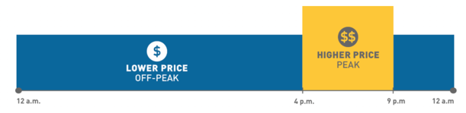

Figure 3: A visual example of a time-of-use rate schedule. (Pacific Gas and Electric, n.d.)

In some cases, your utility might offer a type of program in which they cover some of the costs of the behind-the-meter infrastructure, or own it outright, to help offset the costs of a ZEV deployment (see Section 3.5‑Rate Optimization).

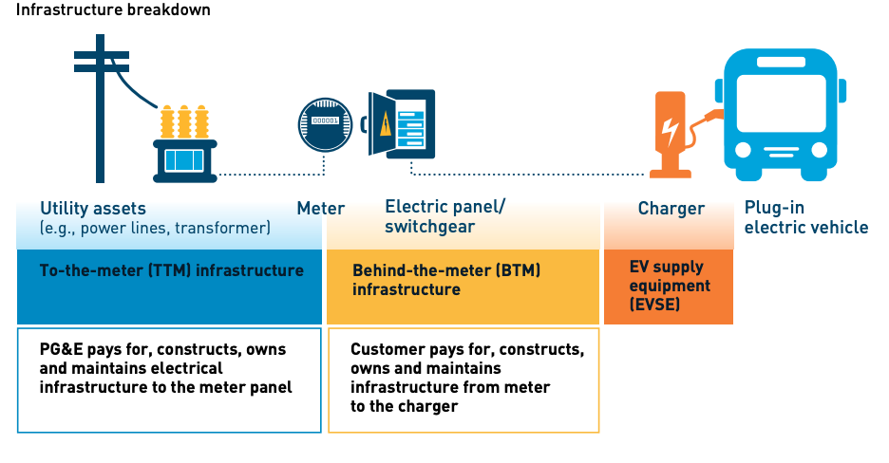

Figure 4: Charging Infrastructure Diagram (Pacific Gas and Electric Company, 2019).

When you start considering ZEVs, it is important to discuss your electrification goals as well as your service needs with your electric utility. Once you are both speaking the same language, you can work together to optimize charging, implement beneficial rates, and make well-informed decisions for your fleet.

## Understanding your Type of Electric Utility

There are three types of electric utilities in the U.S.: investor-owned utilities (IOUs), public power utilities, and electric cooperatives (co-ops). The number of utilities and customers in 2017 is shown by utility type in **Figure 5**. The utility types are described below, with a focus on co-ops, as co-ops are typical utility structures in more rural areas.

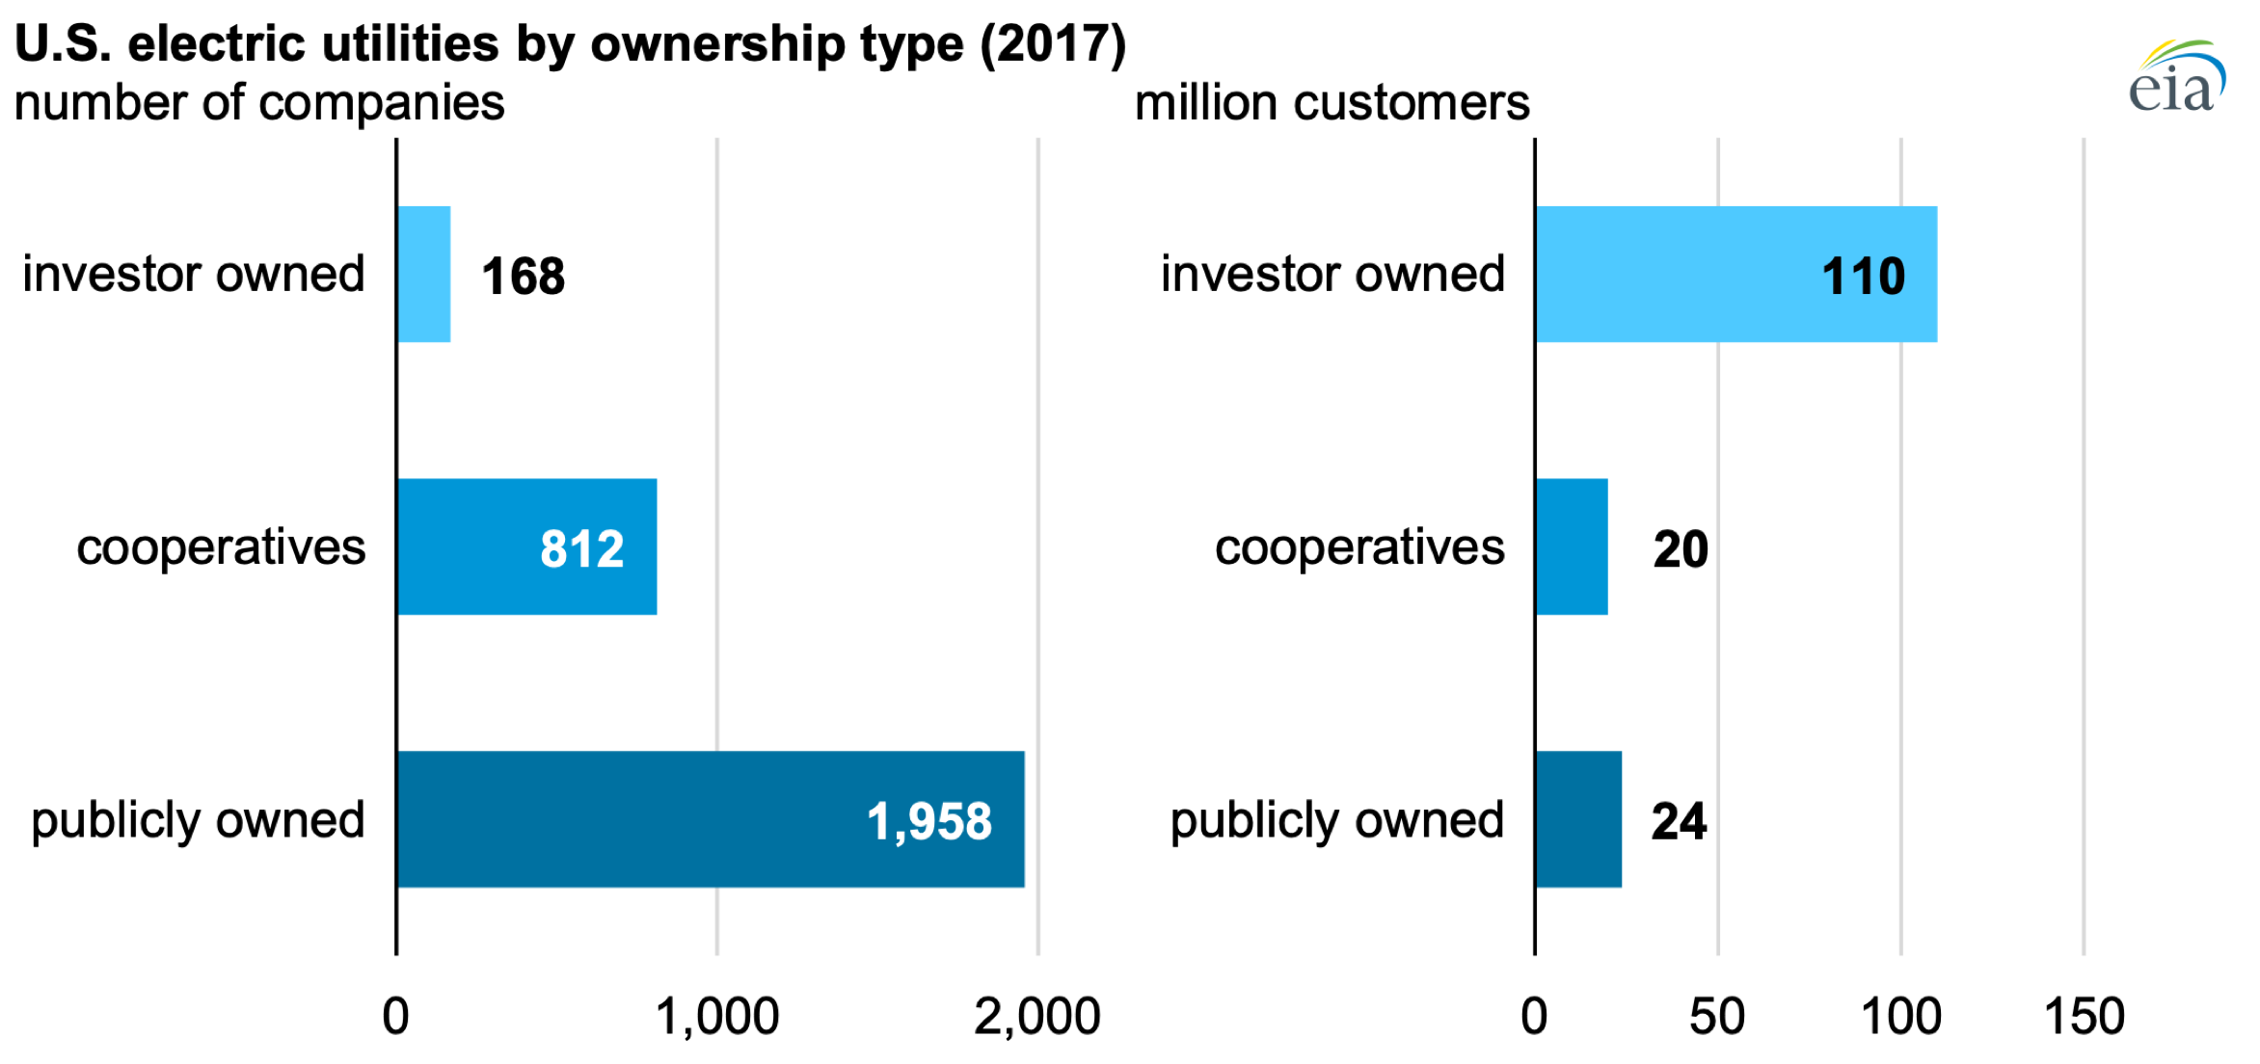

Figure 5. Number of utilities and millions of customers served by utility type in 2017 (EIA, 2019)

Each utility type has a different management structure, and the landscape of utility regulation varies from state to state. There is no “one size fits all” solution for rates and incentives that electric utilities can offer transit agencies.

**Being a “Good Grid Citizen”**

Roaring Fork Transportation Authority (RFTA) is the second largest transit agency in Colorado and the largest rural transit agency in the U.S., operating across a 70-mile service region in western Colorado. RFTA and their electric co-op, Holy Cross Energy (HCE) worked closely through RFTA’s deployment of eight 40’ battery electric buses (BEBs) in their fleet (**Figure 6**). After an initial roundtable discussion with their membership about HCE’s transportation electrification plan, HCE conducted a capacity analysis and determined that they could support up to 27 BEBs with the current infrastructure. Additional buses would require significant investments to upgrade the electrical substation and transformer, which would be unprecedented load growth for HCE.

During initial discussions, RFTA and HCE reviewed how different charging strategies would affect electricity rates. RFTA was able to be flexible with their charging requirements and only charge during off-peak times, limiting HCE’s peak load. Committing to this approach, HCE was able to offer RFTA a special time-of-use (TOU) electric rate with low energy charges during off-peak times and no demand charges.

Working together, RFTA and HCE defined what it means to be a “good grid citizen” and identified a solution that improved operations and kept costs low for both entities.

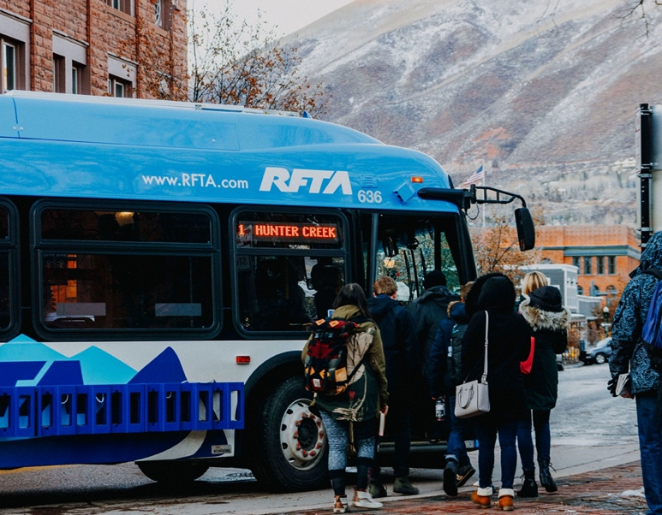

Figure 6. One of RFTA's eight BEBs in revenue service (Image source: RFTA).

### Investor-Owned Utilities

#### Overview

Investor-owned utilities are for-profit enterprises that are owned by stockholders who may or may not be customers or live in the service area. IOUs are governed by a board of directors that are elected by stockholders. IOUs are state-regulated monopolies and are regulated by a state public utilities commission (PUC) or public service commission (PSC). The PUC or PSC determines how much the utility is allowed to invest, what the utility can invest in, how much it can charge, and what its profit margin can be (Girouard, 2015). IOUs are guaranteed a rate of return by the PUC or PSC in return for the risk they bear for investing in new facilities (California Energy Commission, 2019). Tariffs for differing customer types and usage levels attempt to balance the needs of customers and shareholders. If one customer class is given a lower rate, other customers may have to pay more. This balance makes rate design cases difficult as each customer’s advocacy group will argue against increases to their constituents’ rates to give other customer classes a break. This rate setting challenge may be true for other utility types. The two largest IOUs are in California: Pacific Gas and Electric, with 5.48 million customers, and Southern California Edison Company, with 5.07 million customers (Darling & Hoff, 2019).

#### Rate Setting

Electricity rates are set and regulated by the PUC or PSC. Rate setting is a public process that includes public comment periods. Significant regulatory review and public input is required to approve new rates, meaning implementing new rates could take months or years. This process can make it difficult for rates to include incentives for specific transit customers.

### Public Power Utilities

#### Overview

Public power electric utilities are not-for-profit, community-owned organizations. Public power utilities are entities of local or state government and are governed by the city council or an appointed or elected utility commission or authority. Citizens are involved in public power utility decision-making (American Public Power Association, 2016). The largest public power utilities are the Puerto Rico Electric Power Authority (PREPA), with 1.47 million customers, and the Los Angeles Department of Water and Power, a public power utility with 1.43 million customers (Darling & Hoff, 2019).

#### Rate Setting

Electricity rates are typically approved by the utility’s governing body-board or city council in a public format (California Energy Commission, 2019). In limited instances, PUC approval may be required. Since public power utilities rates are often approved through local policy, they can be more responsive to local needs and the local political will. This gives public power utilities more flexibility in working with their customers.

### Electric Cooperatives

#### Overview

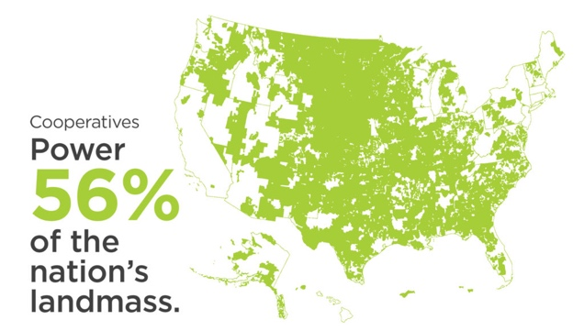

Figure 7. Area of the U.S. powered by electric co-ops (NRECA, 2019)

Electric cooperatives (co-ops) are consumer-owned, not-for-profit companies. Each co-op is led by an elected board made up of members of the community. Cooperatives power 56% of the U.S. by area (**Figure 7**), and power over 20 million businesses, homes, schools, and farms in 48 states (NRECA, 2019). The largest co-op is Pedernales Electric Co-op in Johnson City, Texas with 333,809 members, while the second-largest co-op is Middle Tennessee Electric Membership Corporation in Murfreesboro, Tennessee with over 305,000 accounts (Darling & Hoff, 2019 and Middle Tennessee Electric Membership Corporation, 2020).

Most co-ops are distribution cooperatives that provide their communities with delivery of electricity and other services (NRECA, 2019). Distribution co-ops purchase power from a wholesale energy provider, such as a generation and transmission (G&T) cooperative. About 75% of distribution co-ops belong to a G&T co-op (NRECA, 2019).

Lower population density can drive up electricity distribution costs; co-ops typically have about seven customers per mile, compared to public utilities that might have over 40 customers per mile.

#### Rate Setting

Co-ops are established to provide at-cost electrical service to their members. Rates are set by the elected board of directors (Horan, 2016).

**Evaluate your options**

Besides your electric utility, there may be options in your service area for electricity purchase or generation. Coordinate with your local government to discuss available options.

Other options include:

* On-site energy generation and storage, such as on-site solar or wind
* Power Purchase Agreements (PPAs)
* Community microgrids

## Understanding your Utility Bill

Electric bills consist of many different charges, which vary between power providers. The majority of your utility bill will be charges that are billed by kilowatt (kW), a measure of power, or kilowatt-hour (kWh), a measure of energy.

**Power vs. Energy**

Power, measured in kW, is the rate that energy is consumed or moved. Energy, measured in kWh, is a quantity of work. Using a 50 kW vehicle charger for 2 hours consumes 100 kWh:

***50 kW* × *2 hours = 100 kWh***

Using a 300 kW vehicle charger for 20 minutes also consumes 100 kWh:

***300 kW* × *0.33 hours = 100 kWh***

Power and energy can be compared to filling up a diesel tank. A diesel pump may be able to fill a vehicle at 10 gallons per minute. That flow rate is analogous to the power of a vehicle charger. Using the pump for 15 minutes will dispense 150 gallons of diesel. That total amount of fuel received is analogous to the kWh of energy that a battery would receive during a charging session.

### Typical Bill Components

Electric bill charges are commonly broken down into the following categories, described in more detail below:

#### Fixed Costs

Fixed fees or customer charges are typically established to cover the costs of electricity distribution.

Energy Charges

**Energy Charges = Total energy used (kWh) × Rate ($/kWh)**

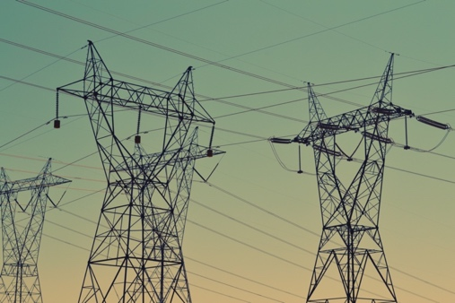

The utility will charge for the total energy consumption, which accrues throughout each month and is typically measured in kWh. Some utilities have seasonal rates, tiered rates for the amount of energy used, or time-of-use rates where there are higher energy charges for peak periods. There may be many line items on a bill that are each billed based on the kWh consumed.

#### Demand Charges

**Demand Charges = Highest average power (kW) over a specified period of time × Rate ($/kW)**

The energy grid is designed so that the largest amount of electricity that is required at one time (i.e., peak demand) can be met. This has important implications for electric vehicle fleets, particularly how much it costs to bring (or expand) service to a facility and how much the public transit agency pays for electricity (EEI, 2019). Demand charges are put in place to cover the cost of the electrical infrastructure needed to meet the highest electricity demand at any time (**Figure 8**). Most commercial utility rates will include demand charges. Demand charges are typically calculated each billing cycle and are based on the highest demand used over a window of time, typically 15- or 30-minutes. Depending on the rate structure, demand rates may also vary by the amount of power used and the time of day it is used. Note that there are a variety of different ways utilities can set up demand charges, so it is important to understand how your specific utility designs demand charges.

Graph showing an example of electricity demand throughout the day

Co-ops typically have a **Fuel Charge** that is established by the G&T or power supplier and is usually a direct pass-through to the customer. Demand charges may be included in this fuel charge.

Figure 8. Example electricity demand throughout a day (Source: We Energies)

#### Other Charges

Surcharges, taxes, and other fees and credits will also be included with the utility bill. These can be related to how the energy was produced, who produced or sold the energy, energy efficiency fees, renewable energy production, the decommissioning of old power plants, city taxes, or rate adjustments during a rate case. The magnitude of these rates can be hard to predict but can account for as much as 30% of the total monthly bill.

# Framework for Building Partnerships Between Transit Agencies and Electric Utilities

**Figure 9** shows a recommended framework to guide your transit agency through coordinating with your electric utility during fleet electrification.



Figure 9. Framework for Transit Agency and Electric Utility Coordination during Fleet Electrification

The overall planning process is flexible and iterative; it should be adapted to meet your transit agency’s specific needs and priorities. The four steps in the shaded box represent the types of coordination that should occur iteratively for each incremental deployment project until you meet your goals. Each step is described in more detail in the sections below.

## Set Fleet Electrification Goals

The first step for transit agencies looking to deploy ZEVs is to establish long-term goals for fleet electrification.

Consider what a full ZEV fleet would look like for your transit agency. Set up a project team with transit agency staff that will be involved in implementing the ZEV project, such as executive leadership, planning, maintenance, operations, and procurement. Establish goals for your transit agency by discussing the following:

* What are your overall goals for ZEV technology deployments, considering your transit agency’s priorities, constraints, and available resources?
* Based on what you know about the current technology and your service requirements, what types of vehicles could you use? How many vehicles would you need to meet your service needs?
* What are the options for installing charging infrastructure at your facility?

Fleet electrification will not happen overnight; therefore, your transit agency should design smaller, incremental ZEV deployments that will work towards your long-term goals. Completing **Table 4** can guide the design of incremental ZEV deployments.

Depending on the size of the deployment, upgrades to your electrical infrastructure may be needed to provide the necessary power to charge your vehicles. Your utility can help you understand when upgrades will be needed and what the associated costs will be. Edison Electric Institute’s (EEI) *Preparing to Plug In Your Bus Fleet: 10 Things To Consider* guide is a great resource that provides more information on electric upgrades and infrastructure in regards to electric bus fleets (EEI, 2019).

Use the attached calculator to estimate the electrical capacity you might need based on vehicle type. Suggested charging requirements for vehicle types often used by rural transit agencies are provided in the calculator. Note that based on the operation of your vehicles, the estimated electrical capacity may not necessarily correspond to your peak demand for your vehicles.

Table 4. Example Template for Designing Incremental ZEV Deployment Projects

| Estimated Timeframe | Number and type of vehicles | Fueling type (e.g., Level II, DC fast charging, on-route charging, hydrogen) | Estimated electrical capacity needed | Possible funding sources | Criteria for evaluating success |
| --- | --- | --- | --- | --- | --- |
|  |  |  |  |  |  |
|  |  |  |  |  |  |
|  |  |  |  |  |  |

There is no one-size-fits-all solution for fleet electrification, and each individual deployment will be different. It is important to plan iteratively and revisit your fleetwide goals at least every few years as the ZEV market advances and as your transit agency’s priorities change. Keep your utility informed of any updates to your electrification plans.

## Technology Assessment

Section 1 contains information on zero-emission transit buses, cutaways, and passenger vans that are available in mid-2020; however, the ZEV industry is rapidly maturing. At the beginning of each of your incremental deployments, evaluate the current zero-emission options for the types of vehicles you are interested in as well as the corresponding charging infrastructure. Your transit agency will also need to consider how the selected technology will impact training, maintenance, and operational costs. Route and charge modeling can help your agency better understand and evaluate operational impacts.

Deploying any zero-emission vehicle requires careful planning to ensure that your transit agency selects the vehicle and fueling technology best suited for your needs. Contact the vehicle OEMs for more detailed information on available vehicle models and expected performance in your service area. CALSTART’s [Zero-Emission Technology Inventory](https://globaldrivetozero.org/tools/zero-emission-technology-inventory/?utm_source=CALSTART+Contacts&utm_campaign=dccf1212bf-EMAIL_CAMPAIGN_2020_05_29_01_51&utm_medium=email&utm_term=0_8aa8b104fe-dccf1212bf-89552726) provides more information on commercially available offerings of zero-emission medium- and heavy-duty vehicles.

## Exploratory Meeting with your Electric Utility and Other Stakeholders

Set up an exploratory meeting with your electric utility to discuss your plans for vehicle electrification before issuing procurements for any vehicles. The meeting should include other members of your project team, including transit agency staff, the state department of transportation (DOT), and other transit agencies or fleet operators in your area that are considering deploying ZEVs. Be sure to describe the purpose and desired outcomes of the meeting (e.g., review electrification plans, required infrastructure upgrades, and rate schedules) to ensure that the correct utility staff members are invited. If your transit agency is served by multiple electric utilities, include staff from each utility in the exploratory meetings.

**Table 5** lists the type of information your transit agency should be prepared to present to the electric utility and stakeholders during the exploratory meeting, along with corresponding information your transit agency should request from your utility to guide decision-making.

Table 5. Suggested Topics to Discuss during an Exploratory Meeting with the Electric Utility and Stakeholders

| Information Provided by Transit Agency | Corresponding Information Provided from Electric Utility |
| --- | --- |
| Short- and long-term goals for electrification—plans for smaller deployments and fleet transition goals | * Electrical upgrades required for each planned deployment project * Recommended schedule for “decision points” on when to install electrical equipment upgrades * Changes to your electricity rate schedule and bill based on the peak demand and planned operation * “Breaking point” for available capacity from existing transformers, feeder lines, and substations from the utility * Information on electric vehicles |
| Funding opportunities under consideration | * Available programs to support electric vehicle deployment, such as:   + Grant cost share   + Capital investments   + Rate or infrastructure incentives * Information on rebates, beneficial rates, pilot programs |
| Planned charging strategy (e.g., depot charge, on-route fast charge, planned charging windows) | * Features of rate schedule to be aware of that will impact utility bill (e.g., demand charges, time of use rates) * Suggestions for charging strategies that will minimize costs * Available opportunities for vehicle-to-grid (V2G) capabilities |
| Carbon reduction goals | * Carbon intensity of electricity generation * Future plans for implementing renewable energy into generation and how that will impact rates in the future |
| Requirements for resilience (e.g., how to maintain operations during a power outage) | * Historical reliability * Options for resilience (e.g., backup generator, microgrid, dual power feeds) |

## Identify Funding Sources

In 2020, ZEVs have higher capital costs than conventionally-fueled vehicles and require the purchase and installation of new charging equipment. There are local, state, and federal funding opportunities available to rural and tribal transit agencies to support the procurement of ZEVs and charging or infrastructure. The National Rural Transit Assistance Program (RTAP) is a great resource for rural and tribal transit agencies looking for additional funding sources. Their website includes a [funding topic guide](https://www.nationalrtap.org/Toolkits/Find-Anything-Toolkit/Free-and-Low-Cost-Resources/Information-and-Best-Practices#Fun) and their Resource Center staff are available to answer questions on funding.

If your transit agency is served by a public power utility or a co-op, the utility staff will most likely wear multiple hats in the community and may be well connected to the county or city governments. Through these connections, your utility will most likely be aware of any available funding initiatives that can help support fleet electrification.

The Federal Transit Administration (FTA) offers several funding opportunities where federally recognized American Indian tribes or Alaska Native villages, groups, or communities as identified by the U.S. Department of the Interior (DOI) Bureau of Indian Affairs (BIA) are eligible applicants or recipients. In 2018, the Cherokee Nation received a grant for over one million dollars from the U.S. DOT’s Low or No Emission Vehicle Program to purchase two electric transit buses and supporting infrastructure (Tulsa Area Clean Cities, 2018).

The following federal and state funding opportunities can be used to procure ZEVs and charging or fueling infrastructure:

* [**FTA’s Low or No Emission Vehicle Program (Low-No)**](https://cms7.fta.dot.gov/funding/grants/lowno)
* [**FTA’s Bus and Bus Facilities Program**](https://cms7.fta.dot.gov/bus-program)
* [**FTA’s Funding for Tribal Entities**](https://cms7.fta.dot.gov/funding/tribal-entities)
* [**Volkswagen Environmental Mitigation Trust**](https://www.vwenvironmentalmitigationtrust.com/)

Coordinate with your State DOT, State RTAP Manager, or FTA Tribal Liaison, and your electric utility when applying for ZEV funding, as they may be aware of other programs for which your transit agency might be eligible for. They also might be able to coordinate a joint grant application with other nearby transit agencies or fleet operators.

State DOTs have spearheaded joint applications on behalf of multiple rural transit agencies under the Low-No Program. In 2018 and 2019, the Vermont Agency of Transportation (VTrans) and Colorado DOT were awarded funds for BEBs for multiple rural transit agencies. Joint grant applications for vehicles, charging infrastructure, or planning studies can be a cost-effective approach and can facilitate sharing lessons learned across project partners.

Your electric utility may be able to contribute cost share to a grant or provide support for the design and installation of charging infrastructure. Some utilities are starting to create rate structures that promote electrification, offer rebates for charging equipment, provide make-ready power distribution, or provide design and build support for fueling installations to incentivize transportation electrification.

### Financial Support from Co-ops

Co-ops may be able to provide financial support for procuring electric vehicles through cost share on grants, or support for purchasing and installing charging or fueling equipment. Examples of potential funding opportunities include:

* **Unclaimed Capital Credits Funds -** Since co-op members are part owners of the co-op, members are eligible to receive capital credits each year, based on the cooperative’s margins. Most co-ops have an unclaimed capital credit fund for credits that cannot be returned to a member in cases where the co-op does not have the most up-to-date contact information for a member that moves or passes away. If unclaimed capital credits remain unclaimed for a certain period of time, the co-op can use those funds as they see fit, usually towards a charitable cause or for programs beneficial to their members (Rocha, 2017).
* **Operation Round up Program –** Some co-ops allow their members to round their monthly bill up to the nearest dollar, and donate those funds for charitable causes.
* **Share costs of electrical upgrades –** Since co-ops are non-profit organizations, the cost of electrical distribution gets passed directly to members. Therefore, your transit agency may be asked to pay up front, or some percentage, for the required electrical upgrades to support electrifying your fleet.

Mountain Parks Electric, an electric co-op in Colorado, used money from their Education Fund to support the purchase and deployment of an electric school bus. The Education Fund is made up of unclaimed capital credits that are at least 3 years old.

## Rate Optimization

Your transit agency’s electricity rate schedule may change as you deploy more ZEVs. Depending on your rate schedule, your charging approach (e.g., the time of day that you charge, how many chargers that you operate simultaneously) may have significant impacts on your costs.

RFTA found that close coordination with their electric utility, HCE, was vital to help understand what charging strategy would keep their costs low. EEI’s *Preparing To Plug In Your Bus Fleet: 10 Things To Consider* guide provides more details on the factors that contribute to the cost of electricity for transit agencies and how that cost can change depending on the charging strategy employed (EEI, 2019).

Some electric utilities have begun to propose alternative rate schedules that promote fleet electrification. Electric utilities are not only modifying rate designs, but some are offering to support infrastructure deployment.

Keep in mind that the landscape of utility regulation will vary state-to-state. Therefore, your utility may not be able to offer a beneficial rate or infrastructure support that has been provided to another transit agency by a different electric utility. Regardless of the programs that your utility can offer, engagement with your electric utility throughout the life of your ZEVs will enhance the likelihood that you have a seat at the table for any discussions about proposed changes to rate schedules or the development of any beneficial programs.

### Beneficial Rates

Utilities have modified rate designs in several ways to support transit agencies, with common modifications being time-of-use revisions and demand charge reductions or eliminations. Ames Electric, a public power utility serving the municipal transit agency in Ames, Iowa, revised their standard commercial rate to be more supportive of transit by waiving the demand charges during a certain time of the day (8PM–4PM). Ames Electric revised the rate after determining that they had surplus capacity during those hours. The rate provides the transit agency with significant cost savings when operating BEBs.

**Coordinating with your G&T Cooperative**

G&T cooperatives design the efficiency, demand response, and rebate programs that distribution co-ops pass on to their consumers. Therefore, your distribution co-op may not have the flexibility to give you an incentive or beneficial rate due to the programs established by the G&T. Ask your co-op to connect you with the G&T co-op or wholesale energy provider. The G&T or wholesale provider may be able to offer you a beneficial rate.

#### Infrastructure Support

Some electric utilities have supported agencies looking to deploy electric vehicles by offering to support infrastructure deployment. Portland General Electric (PGE) worked with TriMet in Portland, OR and the Oregon Public Utilities Commission to implement a program that would allow PGE to own and operate TriMet’s on-route pantograph and plug-in electric bus charging equipment. Ordinarily, regulated utilities are not permitted to own customer-side equipment, but PGE was able to obtain permission to do so in this case. PGE also took an active role in the infrastructure design, permitting, and construction, which streamlined the charger installation process for TriMet. Under this program, TriMet is billed based on the existing rate structures.

**Utility Pilot Programs**

Pilot programs are temporary and of limited scope, intended to have minimal to no impact on ratepayers. Utilities are able to get these approved quicker than other projects, and they will use the results and lessons learned from the pilots to inform longer-term rate structures. It is likely that your vehicles’ service life will exceed the duration of any pilot programs. Make sure to understand how your operational costs may change after a pilot program is over.

## Realize Fleet Electrification Goals

Successful incremental ZEV deployments, informed by close coordination between your transit agency and your electric utility, will help your utility meet your fleet electrification goals.

Fleet electrification requires iterative planning. Evaluate the criteria for success that you outlined in **Table 4** for each incremental deployment, and incorporate lessons learned on how different ZEVs perform in your service area into future plans. After your zero-emission vehicles are in operation, data collection and reporting can be beneficial for your transit agency to more fully understand the performance, reliability, durability, and cost of the deployment. Performance data can bring to light any limitations of the technology that will be helpful when planning future deployments, as well as making any adjustments to the current vehicles in order to get the most effective and efficient use out of them throughout your service area. Evaluating electricity usage data can identify potential operational changes to optimize charging to lower costs. Be sure to share lessons learned with other rural and tribal transit agencies in your area, other fleet operators, and local community stakeholders.

# Additional Resources

* [**Grant Writing 101 for Low or No Emission Program**](https://youtu.be/R8wvajc6WQ0), *National Rural Transit Assistance Program, Federal Transit Administration*
* [**Guidebook for Deploying Zero-Emission Transit Buses**](https://www.nap.edu/download/25842), *Transit Cooperative Research Program*
* [**National Center for Applied Transit Technology**](https://n-catt.org/)
* [**National Rural Transit Assistance Program**](https://www.nationalrtap.org/home)
* [**Rural Transit Fact Book 2017**](https://www.ugpti.org/surcom/resources/transitfactbook/downloads/2017-rural-transit-fact-book.pdf)**,** *Upper Great Plains Transportation Institute*
* [**Preparing to Plug in your Bus Fleet: 10 Things to Consider**](https://www.eei.org/issuesandpolicy/electrictransportation/Documents/PreparingToPlugInYourBusFleet_FINAL_2019.pdf)*, Edison Electric Institute*
* Utility Trade Associations:
  + [**American Public Power Association**](https://www.publicpower.org/)
  + [**Edison Electric Institute**](https://www.eei.org/Pages/default.aspx)
  + [**National Rural Electric Cooperative Association**](https://www.electric.coop/)
* [**Zero-Emission Technology Inventory**](https://globaldrivetozero.org/tools/zero-emission-technology-inventory/?utm_source=CALSTART+Contacts&utm_campaign=dccf1212bf-EMAIL_CAMPAIGN_2020_05_29_01_51&utm_medium=email&utm_term=0_8aa8b104fe-dccf1212bf-89552726),*CALSTART*

References

American Public Power Association. (2016). *Public power for your community.* <https://www.publicpower.org/system/files/documents/municipalization-public_power_for_your_community.pdf>

California Energy Commission. (2019). *Differences between publicly and investor-owned utilities.* <https://ww2.energy.ca.gov/pou_reporting/background/difference_pou_iou.html>

Darling, D., & Hoff, S. (2019, August 15). *Investor-owned utilities served 72% of U.S. electricity customers in 2017.* U.S. Energy Information Administration. <https://www.eia.gov/todayinenergy/detail.php?id=40913>

Edison Electric Institute. (2019, December). *Preparing to plug in your bus fleet: 10 things to consider.*<https://www.eei.org/issuesandpolicy/electrictransportation/Documents/PreparingToPlugInYourBusFleet_FINAL_2019.pdf>

Girouard, C. (2015, April 23). *How do electric utilities make money?* Advanced Energy Economy*.* <https://blog.aee.net/how-do-electric-utilities-make-money>

Horan, J. (2016, January 28). *Rate trends for Minnesota electric cooperatives.* [PowerPoint Slides]. Minnesota Rural Electric Association*.* <https://www.lec.leg.mn/2016/012816Horan.pdf>

Mattson, J. (2017, October). *Rural transit fact book 2017.* Upper Great Plains Transportation Institute. <https://www.ugpti.org/surcom/resources/transitfactbook/downloads/2017-rural-transit-fact-book.pdf>

Middle Tennessee Electric Membership Corporation. (2020, July 1). *Murfreesboro electric merger with Middle Tennessee Electric finalized.* <https://www.mtemc.com/content/med-merger-mte-finalized>

Mountain Parks Electric, Inc. (2020, February 5). *MPE to help West Grand School District get one of the first electric school buses in Colorado.* <https://www.mpei.com/mpe-help-west-grand-school-district-get-one-first-electric-school-buses-colorado>

National Rural Electric Cooperative Association. (2019, October 11). *America’s electric cooperatives.* <https://www.electric.coop/wp-content/uploads/2019/10/Co-op-Facts-and-Figures_WEB_PAGES_10-11-19.pdf>

Pacific Gas and Electric Company. (n.d.) *Shift electricity use to lower-priced times of day.* <https://www.pge.com/en_US/residential/rate-plans/rate-plan-options/time-of-use-base-plan/time-of-use-plan.page>

Pacific Gas and Electric Company. (2019*). Take charge: a guidebook to fleet electrification and infrastructure.* <https://www.pge.com/pge_global/common/pdfs/solar-and-vehicles/your-options/clean-vehicles/charging-stations/ev-fleet-program/PGE_EV-Fleet-Guidebook.pdf>

Rocha, V. (2017, March 2). *Capital credits: Claiming the unclaimed.* Rural Electric Magazine. <https://www.cooperative.com/remagazine/articles/Pages/capital-credits-claiming-the-unclaimed.aspx>

Rosenfeld, J. (2017, December 8). *Small system alternative fuel strategies.* ICF International. <http://onlinepubs.trb.org/onlinepubs/nchrp/docs/NCHRP20-65(72)_GuidanceDocument.pdf>

Shahan, C. (2019, November 28). *Ellen, one of the world’s largest electric ferries, has battery equivalent to 50 Tesla Model S batteries.* <https://cleantechnica.com/2019/11/28/ellen-worlds-largest-electric-ferry-has-battery-equivalent-to-50-tesla-model-s-batteries/>

Shuttle Bus. (n.d.) Motiv Power Systems. Retrieved August 27, 2020, from <https://www.motivps.com/application/shuttle-bus/>

Tulsa Area Clean Cities. (2018, September 7). *Cherokee nation awarded $1.3M for electric buses serving rural transit routes*. <http://www.fuelsfix.com/2018/09/cherokee-nation-awarded-1-3m-for-electric-buses-serving-rural-transit-routes/>

U.S. Environmental Protection Agency. (2019, June). *Fast facts on transportation greenhouse gas emissions.* <https://nepis.epa.gov/Exe/ZyPDF.cgi?Dockey=P100WUHR.pdf>

1. Federal Transit Administration (FTA) funds will not be able to be used to enter into contract with BYD after December 20, 2021 due to subsection 49 U.S.C. § 5323(u), which was added to Section 7613 of the National Defense Reauthorization Act for Fiscal Year 2020 in December 2019.