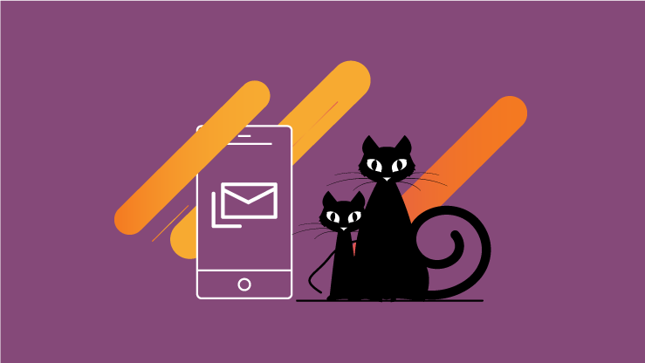

ELM/AURA TEST v.2
This is a test to ensure the updating of a document works in WordPress.

